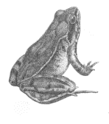Introduction to Organic Chemistry

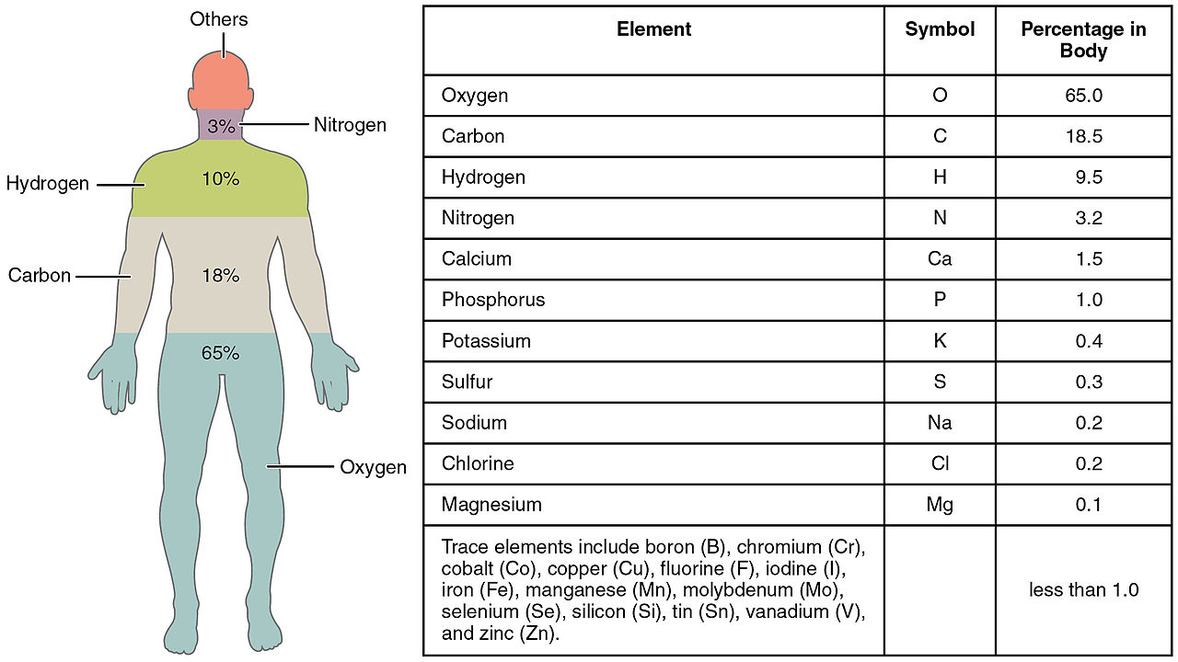

* **Composition of Living Things**
  + Of the 92 elements that naturally occur on Earth, about 25 are found in organisms.
  + Just 4 make up about ________% of a human body’s mass.
    - Carbon (____)

**Of the “others,” Sulfur (S) and Phosphorous (P) will play the biggest roles in what we study.**

* + - Hydrogen (____)
    - Oxygen (____)
    - Nitrogen (____)
* **Organic vs.** 
  + Historically compounds isolated from plants and animals were deemed organic while those traced back to minerals were inorganic.
    - Organic compounds typically had _______________ (____).
  + However, some molecules contain C, such as calcium carbonate (CaCO3) and elemental forms of carbon (diamond and graphite), that are clearing inorganic.
  + Organic compounds are thus defined as containing ____________________________________________________.

|  |  |
| --- | --- |
| **Organic** | **Inorganic** |
| Substance that contains ____________ carbon and hydrogen | Substance that does not contain BOTH carbon and hydrogen. |
| *General rule is that they contain carbon | *Inorganic examples with C: |
| Types Essential to Life:  Carbohydrates (C6H12O6) Lipids  Nucleic Acids Proteins | Types Essential to Life:  Water (H2O) Salts (NaCl)  Acids (HCl) Bases (HCO3-) |

* + Carbon-based molecules form the ____________________ of living things and carry out most of the processes that keep organisms ______________.
* **Chemical Bonds**
  + Elements ______________________ other elements by forming chemical bonds.
  + Bonds can be ionic or covalent, but we will focus on ___________________________ when talking about organic compounds.
  + Covalent bonds are shown as ___________________________________ between atoms in a molecule.
  + 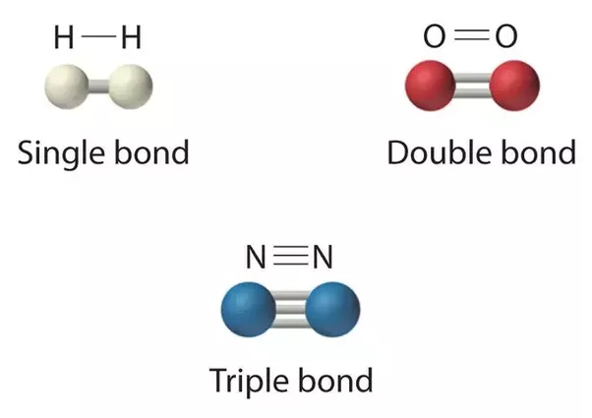There can be single, double or triple covalent bonds

|  |  |
| --- | --- |
| **Element** | **# of Covalent Bonds** |
| Carbon |  |
| Hydrogen |  |
| Oxygen |  |

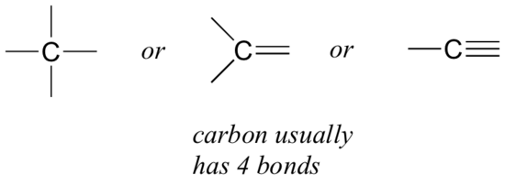

Three fundamental structures:

* + - Straight Chains
    - Branched
    - Rings

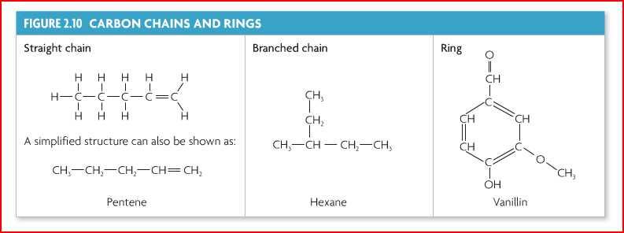

* **Drawing Organic Molecules**
* Full Display: Shows every atom and bond

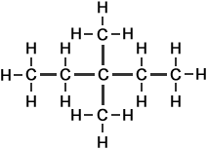

*Can be time consuming to draw out, especially with really big molecules.*

* Skeletal: Only shows bonds between carbons.

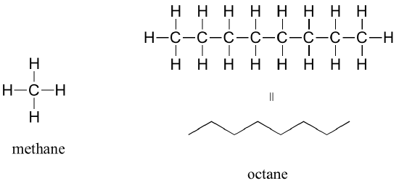

* Each carbon is represented by a bend or an end.
* Bonds between carbons and hydrogens are not shown.
* We can deduce how many hydrogens are present, since we know carbon makes 4 bonds.
* Elements that are not carbon and hydrogen are still shown.
* Hydrogens attached to elements other than carbon are still shown.
* Bonds between carbon and elements other than hydrogen are still shown.

*Let’s Practice:*

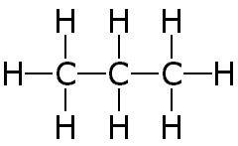

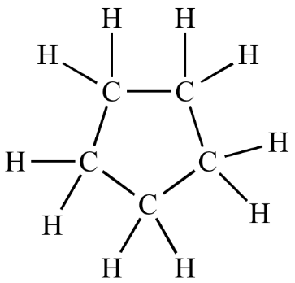

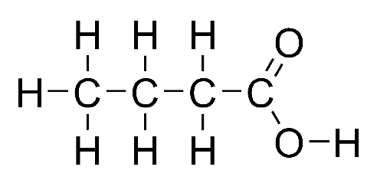

* **Monomer vs. Polymer**
  + Small molecules act as subunits of the entire molecule.
    - ____________________: each subunit is a complete molecule
    - ____________________: a large molecule, or macromolecule, made of many monomers bonded together
  + All of the monomers can be the _______________ (i.e. carbohydrates) or different (i.e. proteins).
* **Building Up and Breaking Down Molecules**

|  |  |
| --- | --- |
| **Forming larger molecules** | **Breaking bigger molecules into smaller ones** |
| Dehydration Synthesis (aka Condensation) | Hydrolysis |
| Sketch: | Sketch: |

* ___________________________________ – Build Up
  + Synthesis: to create (to put together, to make bigger)
  + Dehydration: to take out water
* __________________________ – Break Down
  + Lysis: to _______________
  + Hydro: water (H2O)
* Four Main Classes of Organic ______________________________
  + Lipids
  + Carbohydrates
  + Nucleic Acids
  + Proteins

Four Classes of Macromolecules

|  |  |  |  |  |
| --- | --- | --- | --- | --- |
| **Macromolecule** | **Lipids** | **Carbohydrates** | **Nucleic Acids** | **Proteins** |
| **Types of Atoms:** |  |  |  |  |
| **Monomers made of** |  |  |  |  |
| **Function(s)** |  |  |  |  |
| **Examples** |  |  |  |  |
| **Sketch** |  |  |  |  |

**We will come back to this table after each macromolecule we cover. It may be a good idea to tab this page with something like a sticky note.**