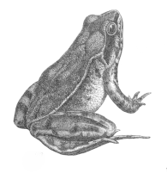Lipids

**STOP AND THINK**

Describe what it means for fat to not be water soluble:

Why would this be useful for cell membranes?

* Lipids – Macromolecule #_____
  + Made up of C, H, and a little bit of O
  + This group has fats and oils, and ______________
  + They are not water soluble
* Fats & Oils
  + Structure:
    - ___________________ + fatty acids
    - Fatty acids are chains of carbon atoms bonded to hydrogen atoms
      * Saturated vs. Unsaturated
  + Function:
    - ______________ large amounts of chemical energy
    - Main component in cell ____________________
  + E.g.: Triglycerides (i.e. Olive Oil, Beef Fat)
* Fats & Oils: Structure
  + Many lipids contain ____ fatty acids bonded to the glycerol
    - Called _________________________
  + These fatty acids are bonded to the glycerol via ______________________________________________

**Example Triglyceride Sketch (*Be sure to label the subunits i.e. glycerol and fatty acids #1,2,3)**

**GO TO NEXT PAGE: (COME BACK TO THIS AFTER ETHANOL & HEPTANE EXAMPLES)**

**WHAT?!? There is a short-cut? Triglyceride Sketch Using Shorthand**

|  |
| --- |
| **Ethanol – C2H5OH** |
| **Heptane – C7H16** |

* Fatty Acids
  + Fatty acids have long ______________________________ chains
    - There is a shorthand for drawing this part of the fatty acid chains:
      * To simplify a hydrocarbon, we draw a kinked line
      * Each bend or end of a line is a ______________ atom
* Saturated vs. Unsaturated
  + A lipid’s _____________________ can be affected by the ____________________ of the fatty acids
    - Saturated: it is “saturated” with hydrogen atoms (maximum number of hydrogen, every spot filled)
    - Unsaturated: at least one double bond between carbon atoms thus the chain has fewer hydrogen
  + Saturated fats are _______________ at room temperature and unsaturated fats are ________________.
    - Saturated fats are found in animals e.g. butter and meat
    - Unsaturated fats are found in plants e.g. olive or peanut oils
  + Saturated and unsaturated fats have different ________________ because of how the molecules pack together.
  + Unsaturated fatty acids have lower ________________________________ than saturated fatty acids.

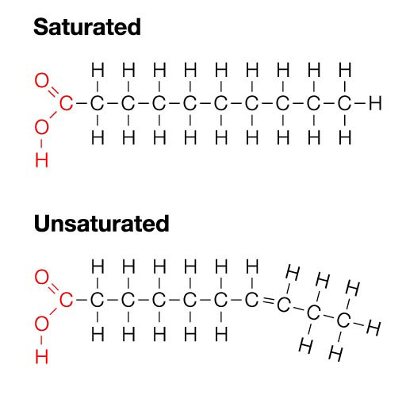

**Example Phospholipid Sketch**

**(*Be sure to label the subunits i.e. glycerol, phosphate group, and fatty acids #1,2)**

**Phospholipid Sketch (Shorthand & Sideways)**

**STOP AND THINK**

**Circle the fatty acid that is more likely to pack together tightly.**

**Explain why:**

* Phospholipid
  + Cell membranes are made up of a lipid similar to triglycerides: a _____________________________.
  + Structure: Glycerol backbone attached to a phosphate group “____________” and 2 fatty acid “_______________”
    - The tails can be saturated or unsaturated
  + 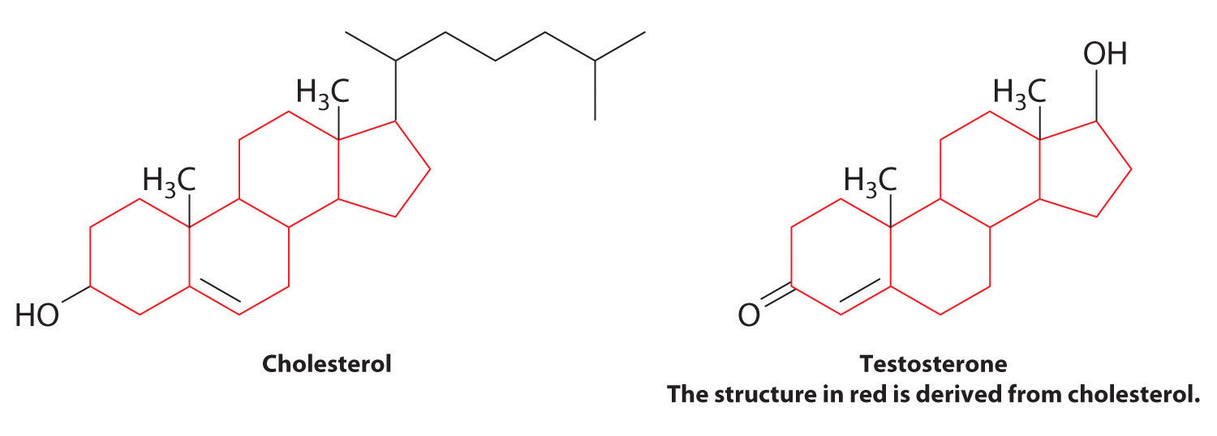Function: Provide a selective ______________ between the inside and outside of the cell and cellular compartments.
* Steroids
  + Structure: 4 interconnected ______________
  + Function:
    - Aid in fluidity/flexibility of cell membrane (______________________)
    - Hormones that act as signaling molecules (i.e. testosterone and estrogen)

**(Now go back to your table of macromolecules and fill in the lipids column!)**