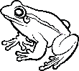
What is Biology?
Characteristics of Life

Why is it important for scientists to agree on a definition of life?

The 8 Characteristics of Life
Characteristic of Life | Explanation | Example/Illustration
1)
2)
3)
4)
5)
6)
7)
8)
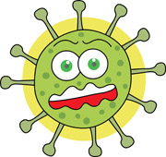
What about Viruses?

