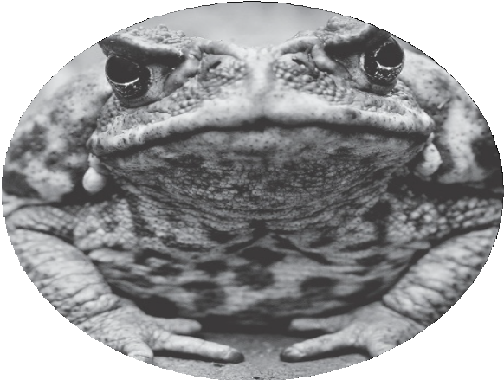
VIDEO
Invasive Toads
Watch a video about Australia‘s battle with invasive cane toads.

- Write a few bulleted notes as you watch the video.

- Explain why cane toads have thrived in Australia and now are considered invasive.

- Brainstorm some ways that scientists might try to control the cane toad population.

VIDEO
Invasive Toads
Watch a video about Australia‘s battle with invasive cane toads.

- Write a few bulleted notes as you watch the video.

- Explain why cane toads have thrived in Australia and now are considered invasive.

- Brainstorm some ways that scientists might try to control the cane toad population.

