- You will release and monitor radio-collared marsh rabbits in two different study areas located in south Florida—the Fakahatchee Strand and Everglades National Park. When you have finished releasing your rabbits, save a copy of your map. Quickly redraw the number of rabbits you released on the map below, or print the image and attach it to this worksheet.

Radio-Collared Rabbits: 50

Fakahatchee Total:
Florida

Everglades Total:

Everglades National Park

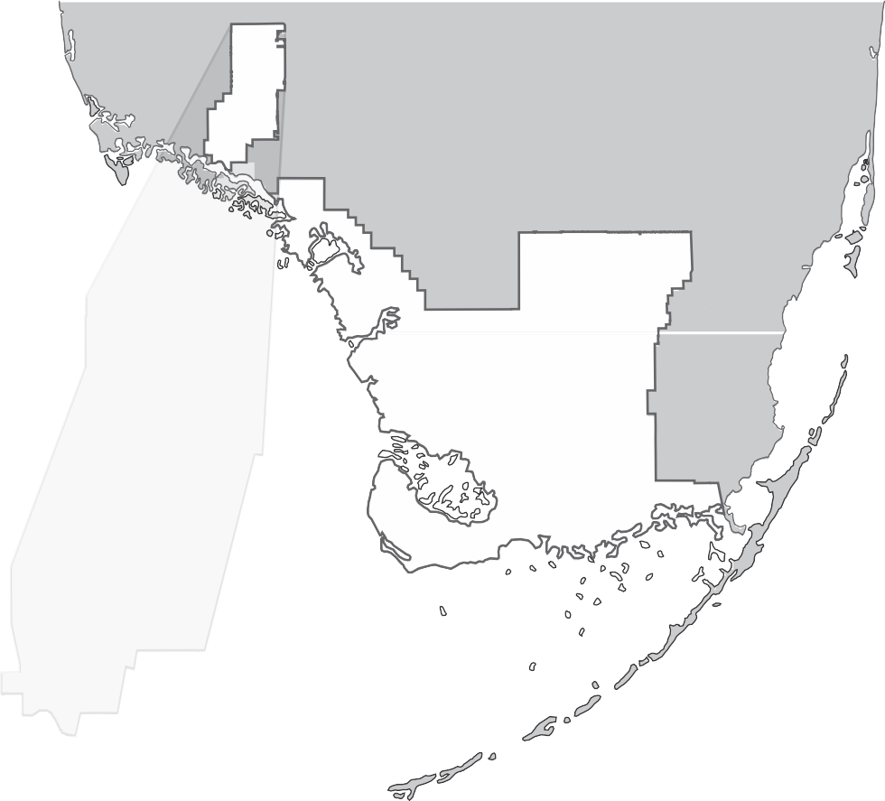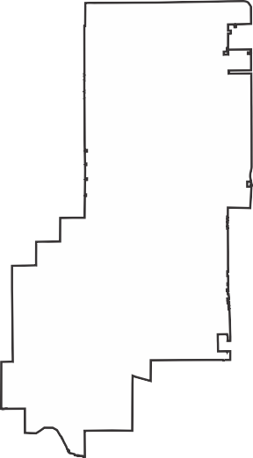
 INTERACTIVITY

Pythons in the Everglades
What is an effect of the introduced Burmese python on the Everglades ecosystem?

Timing Chapter 5, Lesson 2
RECORD DATA AND OBSERVATIO
Parts 1−3
NS

Fakahatchee Strand

- Open your notebook to view the data you collected during your study. Save the table showing your results. You may insert the table at the end of this file, print it and attach it to the end of this sheet, or copy the information from the lab notebook by hand into the table below.

Study Site | Rabbits Released | Rabbit Deaths Due to Predation by: |  |  |  |  | Lost Rabbits | Surviving Rabbits
 |  | Pythons | Birds | Mammals | Other Reptiles | Unknown Animals
Fakahatchee Strand
Everglades National Park

- Repeat your study, this time placing a different number of rabbits in each site. Record your data. Compare your data to the data you collected during your previous yearlong monitoring. In what ways is it similar? In what ways is it different?

- In which study site—Fakahatchee Strand or Everglades National Park—is a marsh rabbit most likely to be killed by a mammal? Use your data to explain your answer.

- According to your data, which study site—Fakahatchee Strand or Everglades National Park —is most likely to have at least one or more surviving rabbits at the end of a year of monitoring? Explain your answer using evidence.

ANALYZE AND CONCLUDE
- Evaluate Solutions How did the use of radio telemetry make it possible for you to discover how the Burmese python is affecting the Everglades ecosystem?

- Analyze and Interpret Data Some species of birds, mammals, and reptiles found in the Everglades are too large or too fast to be eaten by Burmese pythons. Based on your data, how do you think the presence of the Burmese python in the Everglades National Park could nevertheless affect these species?

CONNECT TO THE UNIT PROBLEM
- Connect to Society Think about the invasive species you chose in the Problem Launch. Consider how scientists studied the effects of Burmese pythons on the Everglades ecosystem. Suggest some ways scientists might study the impact of your invasive species on your local ecosystem.

