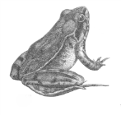 Energy Flow Pyramids
Revised June 2014

TROPHIC LEVELS
An organism’s trophic (feeding) level is determined by its_______________________________________.
There are 3 main trophic levels in a food web. They are:
1. AUTOTROPHS:
- Capture energy from the_______________ (photosynthetic) or _____________________molecules (chemosynthetic) and converts it into ______________________________________.
- Also known as (AKA) _____________________________
  - produces food (make energy storing molecules),
    - Eg.
- 2. HETEROTROPHS-
- AKA ________________________________
  - obtains the energy to build their molecules by ____________________________ plants or other organisms
Includes:
  - primary,
  - secondary,
  - tertiary (etc.) consumers, and
  - decomposers and detritivores
- 3. SAPROTROPHS-
AKA _______________________________________________
An organism that feeds off of __________________________________ organic matter
Examples:
-_________________
-____________________
DETRITIVORES
Organisms that eat detritus, or ________________________________________
  - Eg. ________________________________________________

DECOMPOSERS
A kind of _____________________________________
  - Break down organic matter into _________________________________________.
    - release ___________________________________ back into the environment to be recycled.
      - Eg. _______________________

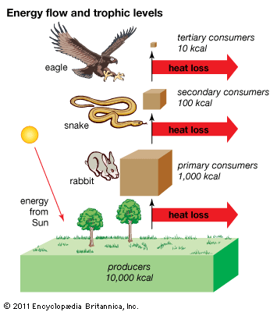
ENERGY
Organisms convert food (___________) into ______________.
This energy is given off as ____________ which is lost to space.
Energy is a ______________________. It is not a cycle.

Energy Flow Pyramids

An energy flow pyramid is a diagram that compares ____________________ used by producers, primary consumers, and other trophic levels.
- As a rule each trophic level receives only __________ from the trophic level below.
- In other words each trophic level loses ____________ heat to the atmosphere.
Study the food web below and convert it into an energy pyramid model. The autotrophs in this food web start off with 123,000 kilojoules of energy and the decomposers are included on the outside of the pyramid. Also label the levels with the following terms:

Autotroph
Producer
Primary consumer
Secondary consumer
Tertiary consumer
Herbivore
Carnivore
Heterotroph
Decomposer/Detritivore

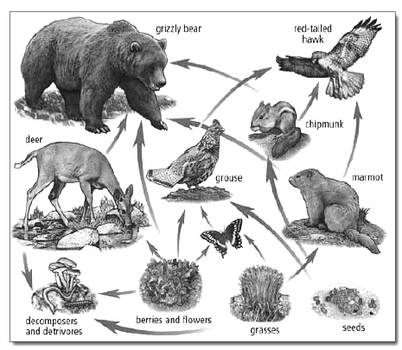

BIOMASS PYRAMID
Biomass is the mass of organisms minus water. Biomass refers to the amount of carbon and other trace elements in an organism’s body contains.
Study the food web below and convert it into a biomass pyramid model. The autotrophs in this food web start off with 5,693,112 Kg of biomass and the decomposers are included on the outside of the pyramid. Also label the levels with the following terms:

Autotroph
Producer
Primary Consumer
Secondary Consumer
Tertiary Consumer
Herbivore
Carnivore
Heterotroph
Decomposer/Detritivore

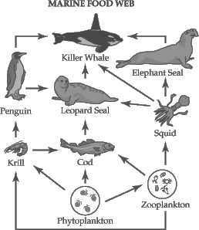
NUMBERS PYRAMID
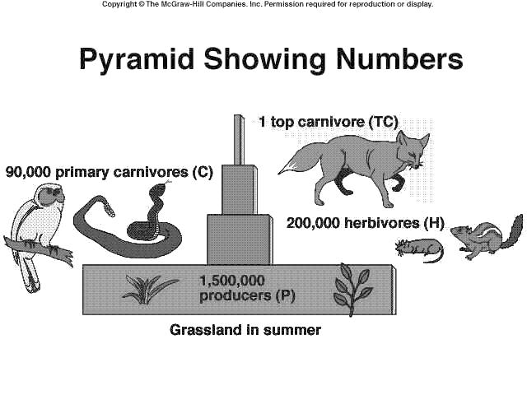
A graphic showing the______________________________ at each trophic level. In this graph you can see that it shows approximately 90% loss of individuals at each trophic level.

HUMAN POPULATION GROWTH
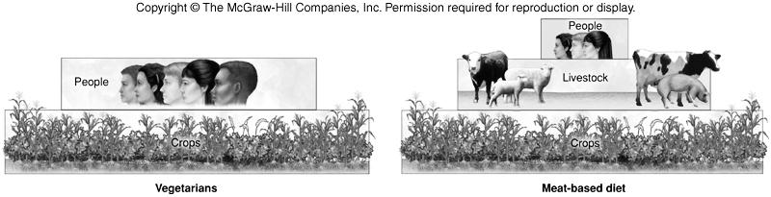
How can more people be supported on Earth when there is a limited supply of resources? It depends on ________________________

