Class Copy

HOW TO MAKE A FORTUNE TELLER OF SCIENCE

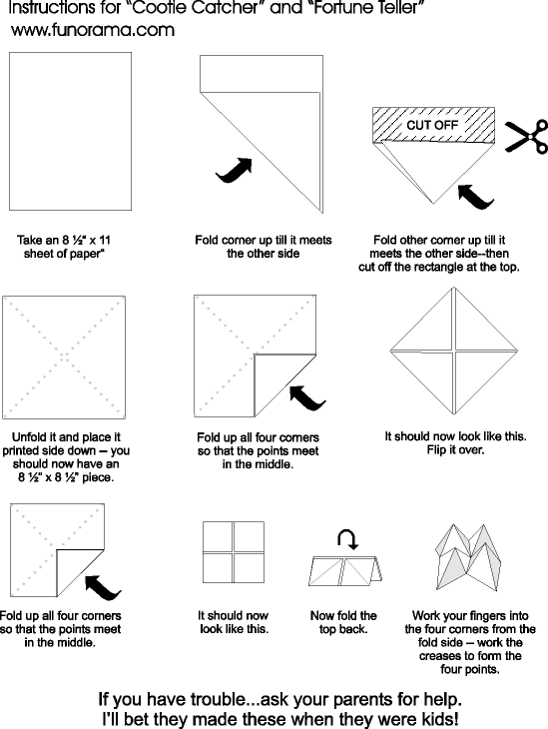

[Type a quote from the document or the summary of an interesting point. You can position the text box anywhere in the document. Use the Text Box Tools tab to change the formatting of the pull quote text box.]

**Fortune Teller for Characteristics of Life**

1. On the outside flap:
   1. Divide each in two (on either side of the fold).
   2. One each half, draw a symbol for a characteristic of life. Use color!
2. On the 1st inside flap, put an explanation of that same characteristic.
3. On the most inside flap, write the title for that characteristic from your notes .
4. Paper clip or tape this into your journal