# CORN DIHYBRID GENETICS

**Class**

**Copy**

**Objectives:**

The goals of this lab is to

1. Study dihybrid inheritance by analyzing the phenotypes of corn kernels from an unknown cross.
2. Determine the genotypes of the parents based on your observations.

**Introduction:**

You will be given an ear of corn. You will examine the effects of two independent genes, one gene for kernel color and one gene for kernel texture. Each of the two genes has two alleles: the gene for kernel color has alleles purple or yellow and the gene for kernel texture has alleles wrinkled or smooth. An individual grain may be:

* Purple and smooth
* Purple and wrinkled
* Yellow and smooth
* Yellow and wrinkled

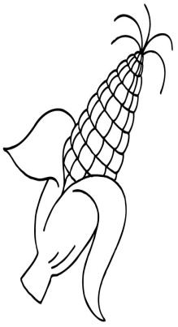Mature corn plants produce ears that contain hundreds of kernels, each formed by the fertilization of an egg by a male gamete. Therefore, each kernel on an ear of corn can grow into a whole new plant, and represents an “individual.” A complete ear represents a compact population of offspring, which may be sampled.  If you look carefully, you should be able to identify four types of kernels on the ear of corn.

**Read the Introduction to answer the following** **Pre-lab Questions:**

1. What are you examining?
2. What are the 2 alleles for kernel color?
3. What are the 2 alleles for kernel texture?

**DO NOT REMOVE the plastic covering over the ears of corn.**

1. How are corn kernels formed?
2. What will each kernel become?
3. What does each complete ear of corn represent?

**Results:**

1. **Record the Possible Genotypes:**

Copy the following T-chart in your lab notebook and write down the possible genotype(s) for the 4 different phenotype combinations keeping in mind that purple and smooth are dominant.

|  |  |
| --- | --- |
| Phenotype | Possible Genotypes |
| Purple and smooth |  |
| Purple and wrinkled |  |
| Yellow and smooth |  |
| Yellow and wrinkled |  |

1. **Record the Frequency of the Phenotypes:**

Come up with a strategy to collect and record the frequency of each phenotype combination for ALL the corn kernels on the ear of corn you are given. Use the pins to mark which rows of corn you have counted, so that you avoid double counting (which could throw off your results).

|  |  |  |
| --- | --- | --- |
| **Phenotype** | **Counts** | **Ratio** (divide each count by the number in the group with the smallest count) |
| Purple and smooth |  |  |
| Purple and wrinkled |  |  |
| Yellow and smooth |  |  |
| Yellow and wrinkled |  |  |

1. **Dihybrid Cross**

Draw a dihybrid Punnett square that will show the frequency of the phenotypes, then fill in the parent generation.