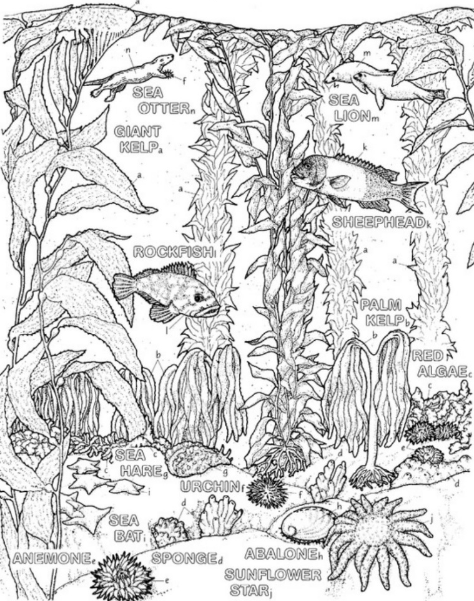
Welcome to Biodiversity!
Course Expectations 2019-2020
How do I contact Ms. Grant?
E-mail: grantl@issaquah.wednet.edu
Website: www.msljgrant.com
Office: 1410K
Room: 2115
Phone/Voice Mail: (425)837-7824

What will we be studying?
Biodiversity is the study of living things, and their environment. We will be studying life on the macro or (large) scale, specifically the ecology of the Sammamish area and the Puget Sound. We will also learn how non-living parts of the environment interact to support life.
Your goal in Biodiversity is to learn how to learn. Science teaches us to question, examine, test and evaluate the world around us. No mater your interests, learning how to apply scientific thought to a problem is a valuable skill!
SEQUENCE OF TOPICS (Issaquah School District Standard Alignment)

- Biodiversity and Ecology
- Planting and Soil
- Chemistry of Life
- Cycles
- Properties of Water
- Modeling the Hydrosphere
- Puget Sound
- Evolution

What are the Class Expectations?
All expectations are designed to provide a productive learning environment for all students. Remember: you are not the only student! Consider how your actions will impact your classmates.
- BE ON TIME! Being late distracts other students from their tasks, as well as limits your own learning. Be seated and prepared to learn at the “bell,” so you and your classmates don’t miss anything!
- BE PREPARED! When you forget something (like your comp book) you are more likely to miss important information. Always come to class with the proper materials (binder, compbook, writing utensils).
- SHOW DIGINTY! Everyone deserves to be treated with dignity. Treat your classmates (and your teacher) how you would like to be treated!
- LISTEN & COOPERATE! Working with others is a part of life, though it can be very challenging. In groups, make sure you practice active listening, and productive group work strategies!
- CONSIDER YOUR CLASSMATES! Your actions impact more than just you. Remember to think of your classmates before you act!
- DEMONSTRATE A GROWTH MINDSET! It can be easy to fall into a fixed pattern of thought. Demonstrate the “See, Hear, Think” norms of a growth mindset in this classroom!
- NO NEGITIVE SELF-TALK! If you wouldn’t say it to your bestie, don’t say it to yourself!!!!
Rules of the classroom
These are non-negotiable, and designed for safety and learning
- NO FOOD OR DRINK IN THE LAB AREA OF THE CLASSROOM. Absolutely none.
- BE SAFE! You and your parent must sign the district’s “Safety Rules in the Science Classroom” agreement. Inability to follow the safety rules will result in the student being released from the class.
- NO PERSONAL DEVICES WITHOUT PERMISSION! If is scientifically proven you’re your phone is a distraction, and that you will learn less when it is visible. There is a time for phones, and class is not it! Learning how to resist the pull of the phone is an essential life skill

What happens if I don’t follow the expectations or rules?
Mistakes happen! Consequences are designed to help you learn from a mistake, and move on.
- General (Depending on Severity)…1st time-Discussion with Ms. Grant
2nd time-Parent/Guardian Phone Call
3rd time-Administrative Write Up
- Cheating ………………………….....Refer to student hand book
- Technology………………………….1st time-Discussion with Ms. Grant (warning)
2nd time-Confiscated for the period
3rd time-Confiscated and given to the administration

What materials do I need to be successful?
- Composition Notebook (NOT spiral bound)
- Pencils with erasers
- Black or blue pens
- Red (or non- blue/black) pens
- 3-ring binder dedicated solely to Biology with Lind Paper (1-in should do).
- Calculator-4 function
- Colored pens or pencils
How will my Grade be calculated?
Grades will be weighted each Semester by the categories:
- 10% Lab/Activity Participation
- 25% Laboratory Work: Formative Assessment
- 25% Classwork/Assignments: Formative Assessment
- 30% Tests: Summative Assessments
- 10% Final

What if I miss class?...EXCUSED ABSENCES
All work can be found on my website, or with the EA in the classroom. Make up work must be done OUTSIDE of class. It is your responsibility to find out what you have missed.
- Look at my website to find out what you missed (this should be done outside of class).
- Get the copies and notes that you missed from the EA.
- Complete make up work.
- Make sure Ms. Grant grades your work.
- If you need more help, make an appointment with me outside of class

Biology Course Expectations 2019/2020 Signature Sheet
Submit to Ms. Grant, stating that you and your parent/guardian have read and understood all expectations.

Please take this home and go over it with your guardian. Sign this page of the packet. Bring this page back by _________________________. You will not be allowed to receive any credit after that date until it is in. Please keep the expectations in the front of your science notebook.

I have read the following and understand the course expectations for Biology

Student Name/Period: ________________________________________________________________________________________________________

Student Signature: ____________________________________________________________________________________________________________

Guardian Name Printed: _____________________________________________________________________________________________________

Guardian Signature: __________________________________________________________________________________________________________

Please supply the following information:

Parent/Guardian email: Most contact will be done by email, so please enter the best contact email

Home number/best time to call:

Parent/Guardian work numbers/cell phone number/best time to call:

Any other things that I, as a teacher, should know?

