**Biology EOC Practice Test** (from 2014 Updates with some short answer from 2013 and 2012)

**Directions: Answer questions 1 through 4. They are not connected to a scenario.**

**1** Coyotes eat proteins in food. The proteins break down due to enzymes produced in the stomach of the coyote. The production of these enzymes then causes more enzymes to be released in the stomach. Which process does this describe?

o **A.** Meiosis

o **B.** Diffusion

o **C.** Feedback

o **D.** Respiration

**2** What is one purpose of ATP molecules in plant and animal cells?

o **A**. To increase the rate of diffusion across cell membranes

o **B**. To decrease the rate of chemical reactions

o **C**. To store energy used for cell processes

o **D**. To pass genetic traits to offspring

**3** A strand of DNA contains the sequence GGC-CAT. What is the complementary strand of **mRNA** for this sequence?

Write your answer in the box.

|  |
| --- |
|  |

**4** Which scientific evidence would show that two species of birds are closely related?

o **A**. The two bird species have similar DNA sequences

o **B**. The two bird species eat many of the same insects

o **C**. The two bird species are found in the same area

o **D**. The two bird species have similar feather colors

**The Moths and the Trees**

**Directions: Use the following information to answer questions 1 through 6.**

The Forest Ecosystem diagram shows part of a forest ecosystem. Tussock moths are native to the forest ecosystem. In the fall, tussock moths lay eggs on Douglas fir trees. In the spring, tussock moth larvae eat the needles of the Douglas fir trees.



**5** The traits of populations in the forest ecosystem have changed over time. What caused

the traits to change?

o **A**. Natural selection

o **B**. Lack of mutations

o **C**. Unlimited resources

o **D**. Asexual reproduction

**6** Which change to the forest ecosystem could **limit** the growth of the tussock

moth population?

o **A**. Decrease in competition

o **B**. Reduction in disease

o **C**. Fewer predators

o **D**. Loss of habitat

**7** Students asked the following question.

**Question:** What is the effect of the size of a moth population on the growth of trees in an ecosystem?

Which reason describes why this question is scientifically testable?

o **A**. All moths require trees for food.

o **B**. Many different ecosystems include trees.

o **C**. Annual data can be collected because trees grow slowly.

o **D**. Both tree height and moth population size can be measured.

**8** If the tussock moth population increases rapidly, trees that people want to use can be damaged. One solution is to use an insecticide that kills moths to keep the moths from damaging trees.

Describe two possible **unintended** consequences of using insecticides.

In your description, be sure to:

• Describe two effects of insecticide use on the forest ecosystem other than the intended reduction of moths to protect the trees.

• Describe how each effect causes a change in **another** part of the forest ecosystem.

|  |
| --- |
| One unintended consequence: |
|  |
|  |
|  |
|  |
|  |
| Another unintended consequence: |
|  |
|  |
|  |
|  |
|  |

**9** In some species of moths, large wings are dominant over small wings, and yellow wings are dominant over white wings.

What percent of the offspring of two moths with small white wings will also have small white wings?

o **A**. 0%

o **B**. 25%

o **C**. 75%

o **D**. 100%

**10** How do tussock moths obtain energy in cellular respiration?

o **A**. By taking in water

o **B**. By releasing oxygen

o **C**. By breaking down glucose

o **D**. By inhaling carbon dioxide

**Along a Stream**

**Directions: Use the following information to answer questions 7 through 13.**

Paige and Logan did a field study to learn about the distribution of plants near a stream. They found the *high flow line* (the highest level stream water reaches) to be 4 meters from the stream. Paige and Logan counted the number of plants at, below and above the *high flow line* of the stream.

**Field Study Question:** How does distance from the stream affect the number of plants growing there?

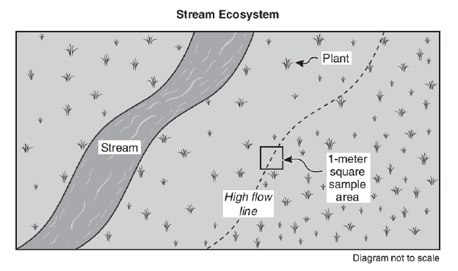

**Procedure:**

1. Go to the field study location when the stream is low. Record the location, date and time.

2. Select a 1-meter square sample area two meters from the stream.

3. Count the number of plants within the sample area. Record as Trial 1 for two meters.

4. Repeat steps 2 and 3 in three different locations as Trials 2 through 4.

5. Repeat steps 2 through 4 at distances four and six meters from the stream.

6. Calculate and record the average number of plants at each distance from the stream.

**Environmental Conditions:**

Location: Near the stream behind the school

Date and Time: July 10, 2:00 to 4:00 P.M.

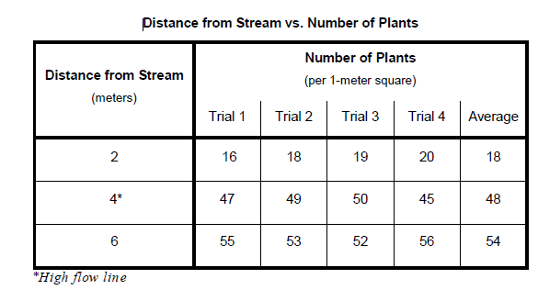

**11** The *high flow line* can move if the amount of water in a stream changes. Based on Paige and Logan’s results, what would happen to the plants if the *high flow line* moved farther from the stream?

o **A**. The number of plants four meters from the stream would decrease.

o **B**. The mass of the plants two meters from the stream would increase.

o **C**. The height of the plants six meters from the stream would decrease.

o **D**. The reproduction rate of plants four meters from the stream would increase.

**12** Paige and Logan counted a total of 480 plants in 12 square meters. What was the population density of these plants?

o **A**. 40 plants per square meter

o **B**. 480 plants per square meter

o **C**. 492 plants per square meter

o **D**. 5,760 plants per square meter

**13** How would a fish population affect the stream ecosystem?

o **A**. Fish would lower the water temperature.

o **B**. Fish would produce oxygen from the water.

o **C**. Fish would block sunlight, increasing plant growth.

o **D**. Fish would produce waste, providing nutrients to plants.

**14** A year after their field study, Paige and Logan collected new data and found an average of only 5 plants at locations two meters from the stream. Which could explain why the number of plants two meters from the stream decreased?

o **A**. The new data were collected later in the day.

o **B**. The topsoil had been washed away by a flood.

o **C**. A larger sample area was used to count plants.

o **D**. The animals that ate the plants had moved away.

**15** Why do frogs and fish in the stream have similar genes?

o **A**. Frogs and fish are made of molecules.

o **B**. Frogs and fish share a common ancestor.

o **C**. Frogs and fish get nutrients from the stream.

o **D**. Frogs and fish compete in the stream ecosystem.

**16** People often build homes near streams. Which action represents sustainable use of resources in the construction of new homes?

o **A**. Installing furnaces that burn fossil fuels

o **B**. Installing refrigerators made in another country

o **C**. Using materials from old buildings for new homes

o **D**. Using wood from old-growth forests for new homes

**17** Plan a field study to answer the question in the box. You may use any materials and equipment in your procedure.

Be sure your procedure includes:

• logical steps to do the field study

• conditions to be compared

• data to be collected

• method for collecting data

• how often data should be collected and recorded

• environmental conditions to be recorded

|  |
| --- |
| **Field Study Question: How does water depth affect the temperature of water in a stream?** |
| Procedure: |
|  |
|  |
|  |
|  |
|  |
|  |
|  |
|  |
|  |
|  |
|  |
|  |

**18.** Some bears are getting into trash cans at campgrounds near the forest. The park

rangers plan to trap and relocate these bears to solve the problem of these bears getting

into the trash. Describe two constraints other than cost that park rangers could

encounter while trapping and relocating these bears.

In your description, be sure to:

• Identify **two** constraints on trapping and relocating these bears other than cost.

• Describe how **each** constraint is a limitation.

|  |
| --- |
| One Constraint: |
|  |
|  |
|  |
|  |
| Another Constraint: |
|  |
|  |
|  |
|  |

**Blueberry Blues**

**Directions: Use the following information to answer question 19.**

José and Tasha noticed last year the blueberry plants in their neighborhood garden had many flowers, but produced only three kilograms of berries. They wanted to change the garden so the blueberry plants would produce more blueberries this summer. While making the changes to the garden, José and Tasha documented the stages of their design process as follows.

**Problem:** Change the neighborhood garden so the existing blueberry plants will produce more blueberries.

**Research the Problem:** Research what blueberry plants need to grow, be healthy, and produce berries.

**Plan Summary:** Add a bee house and some lavender plants to the neighborhood garden to attract more bees to the blueberry plants.

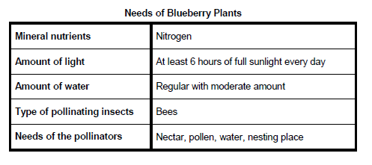**Explore Ideas:**

✓ Add a layer of bark to the garden so the soil can hold more water.

✓ Water the plants at night so the water will evaporate more slowly.

✓ Add fertilizer to increase the mineral nutrients in the soil.

✓ Add flowers like lavender, roses, or pansies.

✓ Put a bee house near the plants.

**Steps to Do the Plan:**

1. Put a bee house in the middle of the blueberry plants.

2. Plant lavender plants around the edge of the blueberry plants.

3. Water the garden every day.

4. Remove the weeds in the garden every week.

**Diagram of Solution:**

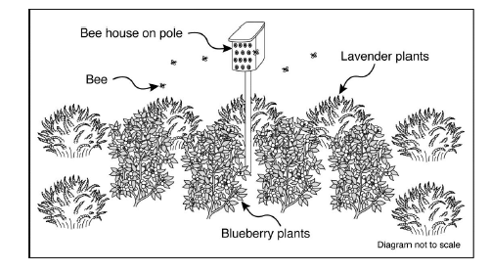

**Test Solution:** Measure and record the mass of all the blueberries harvested this year. Compare the mass of the blueberries this year to the mass of the blueberries last year.

**Test Results:** Ten kilograms of blueberries were harvested, which is seven kilograms more than last year.

**19.** Jose and Tasha want to improve the soil in the garden by increasing the population of worms in the soil. Describe how to begin solving this problem.

Be sure to describe the following stages in your design process:

• **Research the Problem:** Describe any scientific information needed to solve the problem and how to collect that information.

• **Explore Ideas:** Describe several possible solutions to the problem, including any useful scientific concepts.

|  |  |
| --- | --- |
| |  | | --- | | **Problem: Increase the population of worms in the soil** | |
| **Research the Problem:** |
|  |
|  |
|  |
|  |
| |  | | --- | | **Explore Ideas:** | |
|  |
|  |
|  |
|  |