Buckets WS: Consequences of Passive Transport
This label describes what the membrane is permeable to. For example, this membrane IS permeable to water but NOT salt.

For each scenario, answer the following questions:
- Will the H₂O move?
- Will the solute move?
- Will they reach equilibrium?
- If equilibrium is reached, what will the solute
concentration on each side?
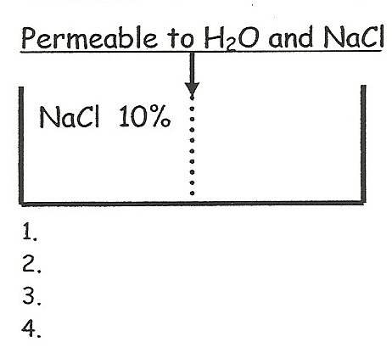 | 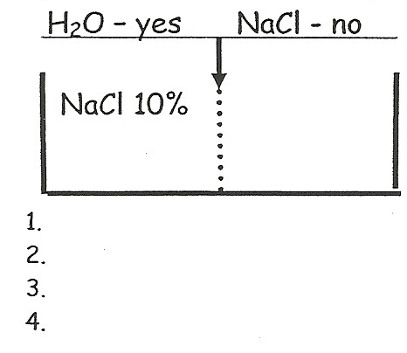
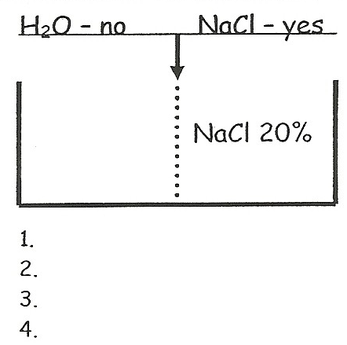 | 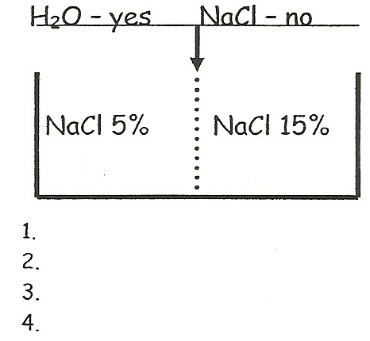
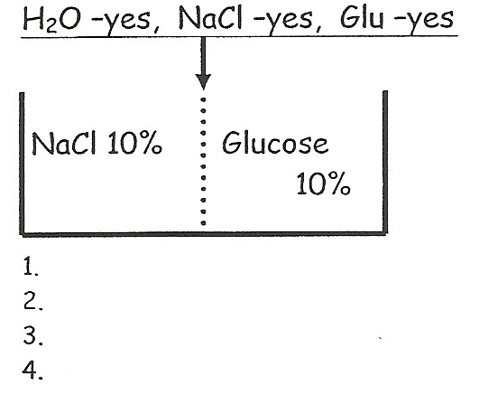 | 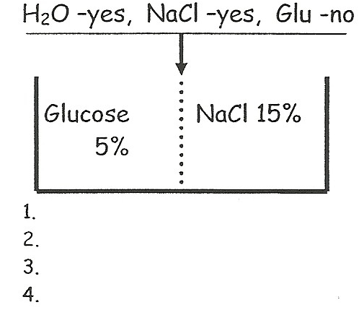
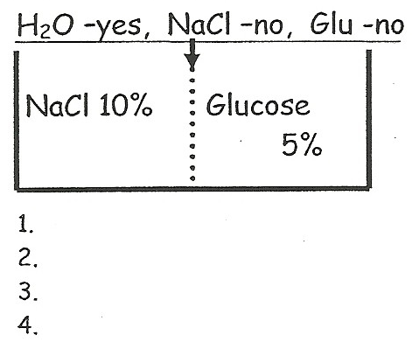 | 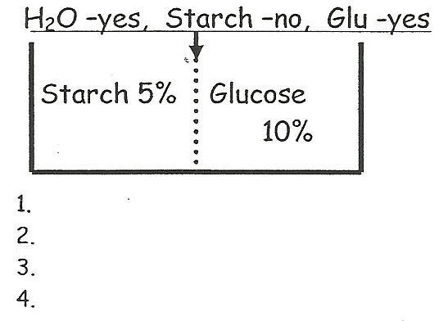
Application of Osmosis
A plant cell (elodea), red blood cell (RBC), a seaweed cell (plantlike protest), and an amoeba (animal-like protest) were placed in 2 different environments. Draw the cell in each environment. Show what happened to the water of the cell with an arrow. Label each environment as hypertonic, hypotonic or isotonic. State any consequences that could occur to the cell in each environment. Don’t forget your arrow in your diagram for each question!

Cell: | Environment: 100% Distilled H₂O  ( 0% solute) | Environment: NaCl & H₂O solution  (3.5% NaCl)
RBC  (.9% solute) | Movement of water:__________________  Type of environment:_________________  Possible consequence:_________________ | Movement of water:__________________  Type of environment:_________________  Possible consequence:_________________
Elodea  (2.0% dissolved solute) | Movement of water:__________________  Type of environment:_________________  Possible consequence:_________________ | Movement of water:__________________  Type of environment:_________________  Possible consequence:_________________
Seaweed  (6% dissolved solute) | Movement of water:__________________  Type of environment:_________________  Possible consequence:_________________ | Movement of water:__________________  Type of environment:_________________  Possible consequence:_________________
Amoeba  (1% dissolved solute) | Movement of water:__________________  Type of environment:_________________  Possible consequence:_________________ | Movement of water:__________________  Type of environment:_________________  Possible consequence:_________________

