CLADOGRAM ANALYSIS
What is a cladogram? It is a diagram that depicts evolutionary relationships among groups. It is based on PHYLOGENY, which is the study of evolutionary relationships. Sometimes a cladogram is called a phylogenetic tree (though technically, there are minor differences between the two).
In the past, biologists would group organisms based solely on their physical appearance. Today, with the advances in genetics and biochemistry, biologists can look more closely at individuals to discover their pattern of evolution, and group them accordingly - this strategy is called EVOLUTIONARY CLASSIFICATION
CLADISTICS is form of analysis that looks at features of organisms that are considered "innovations", or newer features that serve some kind of purpose. (Think about what the word "innovation" means in regular language.) These characteristics appear in later organisms but not earlier ones and are called DERIVED CHARACTERS.

Fill out the following character matrix. Mark an “X” if an organism has the trait.

 | Cells | Legs | Antenna | Wings | 2 sets of wings
Worm
Spider
Carpenter Ant
House fly
Dragonfly

In the box below, create a cladogram based off your matrix.

- According to your cladogram, which two species are more closely related: worms and spiders or worms and ants? How do you know?

- According to your cladogram, what species are dragonflies most closely related to? How do you know?

- In a different colored writing utensil, add a June Bug to your cladogram based on its characteristics. June bugs have cells, legs, antenna, and two sets of wings. However, one set of wings has been modified into a shell.

Use the following cladogram to answer the questions below.
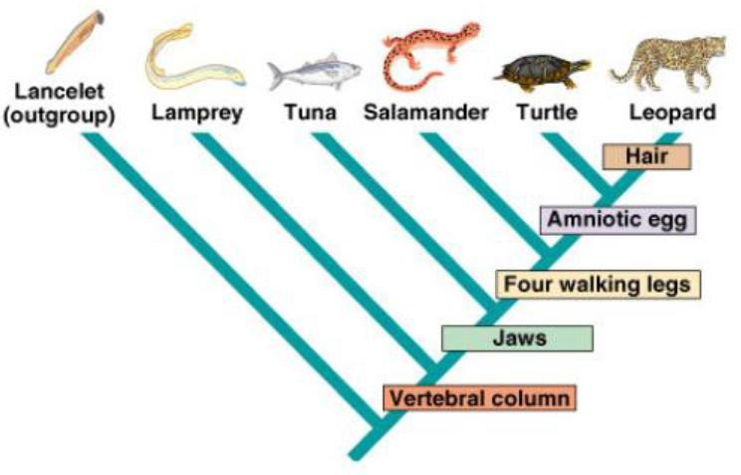

- What trait separates lampreys from tuna on this cladogram?

- What separates a salamander from a turtle?

- Which organism is most related to the leopard?

- Which organism’s DNA will differ the most from the leopard? Why?

Use the following cladogram to answer the questions below.
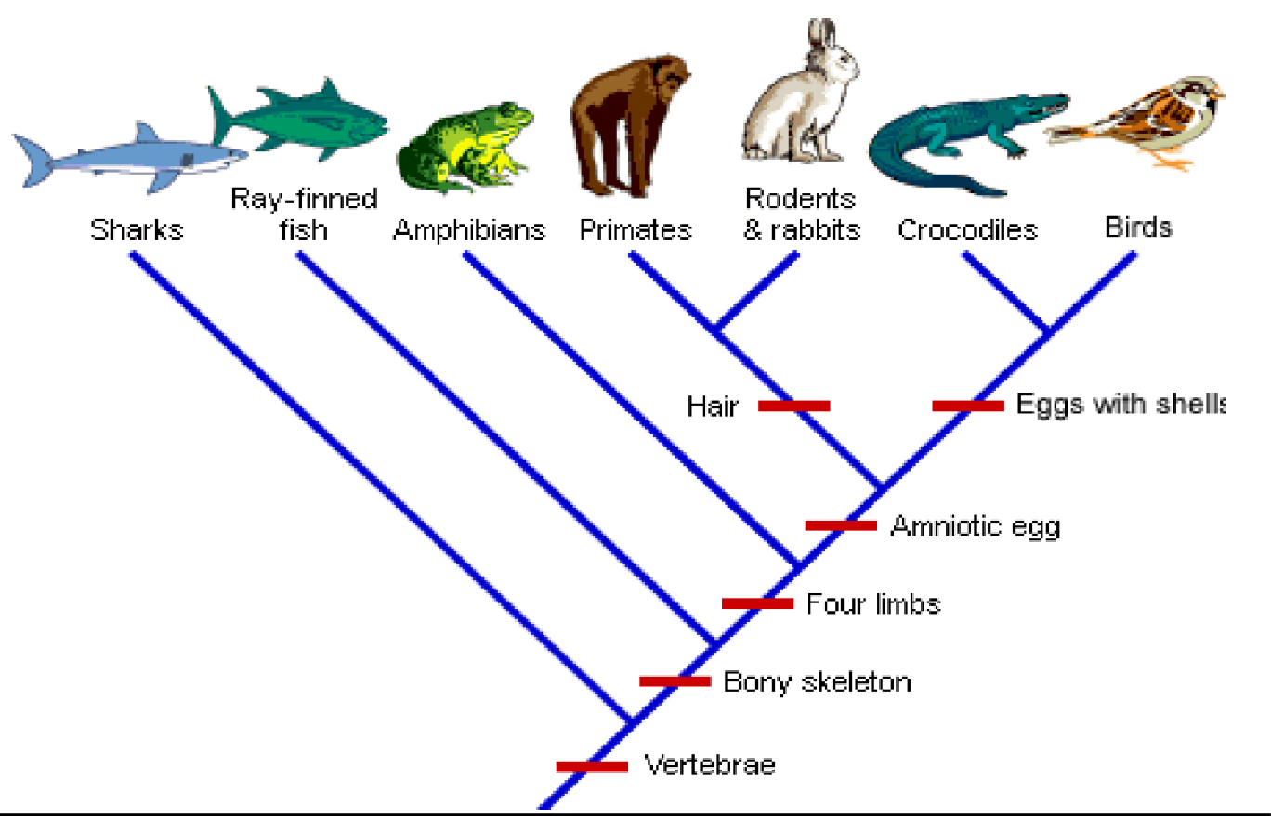
- What separates rabbits/primate from the crocodiles on this cladogram?

- Which organism is most related to the rodents and rabbits on this cladogram?

- What 5 traits do the bird and its closest relative share? a.

b.

c.

d.

e.

- Which organism will have DNA most similar to the bird? Why?

- Which organism’s DNA will differ the most from the bird? Why?

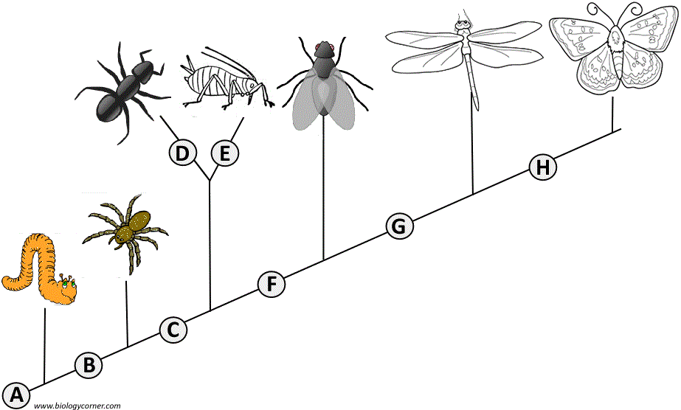
Examine the cladogram below. Each letter represents a derived characteristic. Match the letter to its characteristic.

- Wings
- 6 legs
- Segmented Body
- Double set of wings
- Cerci (back appendages)
- Crushing mouthparts
- Legs
- Curly Antennae

Circle the correct answer for the cladogram question below.

The cladogram shows the evolution of land plants as indicated by fossil records.
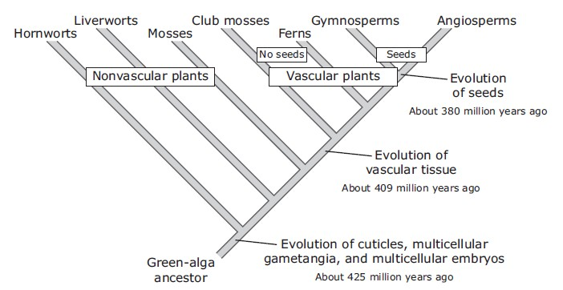

Which discovery would challenge the validity of this cladogram?
  - A large aquatic vascular plant about 200 million years old
  - A species of algae that has existed for less than one million years
  - A moss species that has existed for less than 380 million years
  - A fossil of a fern more than 425 million years old

Biologically, one could use anatomical features, behavior, or molecular similarities and differences in constructing a cladogram. Molecularly, one could look at the number of mutations in a common strand of DNA. Another way would be to compare strings of amino acids and note differences in the order of the amino acids.
Cytochrome c is a protein located in the mitochondria of cells involved with cellular respiration. Below is a table showing the amino acid sequences for cytochrome c in several organisms.

Organism | Biochemical Data
Amoeba | Amino Acid Sequence: ISO-SER-ASP-GLN-PHE-ILE-LEU-GLN-SER-ARG-LEU-LEU-HIS DNA Sequence: ATTAGCGACCAGTTTATCCTACAATCCCGTCTACTTCAT
Kangaroo | Amino Acid Sequence: LEU-ISO-PRO-PRO-PHE-ILE-LEU-LEU-SER-HIS-LEU-LEU-SER DNA Sequence: CTAATCCCCCCGTTTATCCTACTTTCCCATCTACTAAGT
Earthworm | Amino Acid Sequence: LEU-ISO-ASP-PRO-PHE-ILE-LEU-HIS-SER-ARG-LEU-LEU-ARG DNA Sequence: CTTATCGACCCGTTTATCCTACATTCCCGTCTACCTTCGT
Cat | Amino Acid Sequence: LEU-ISO-PRO-PRO-PHE-ILE-LEU-LEU-SER-HIS-LEU-LEU-SER DNA Sequence: TTAATCCCCCCGTTTATCCTACTTTCCCATCTACTAAGT
Shark | Amino Acid Sequence: LEU-ISO-PRO-PRO-PHE-ILE-LEU-LEU-SER-ARG-LEU-LEU-ARG DNA Sequence: CTTATCCCCCCGTTTATCCTACTTTCCCGTCTACTTCGT
Dolphin | Amino Acid Sequence: LEU-ISO-PRO-PRO-PHE-ILE-LEU-LEU-SER-HIS-VAL-VAL-SER DNA Sequence: CTAATCCCCCCGTTTATCCTACTTTCCCATGTAGTAAGT
Lizard | Amino Acid Sequence: LEU-ISO-PRO-PRO-PHE-ILE-LEU-LEU-SER-ARG-LEU-LEU-ARG DNA Sequence: CTAATCCCCCCGTTTATCCTACTTTCCCGTCTACTTCGT
Sponge | Amino Acid Sequence: ISO-ISO-ASP-GLN-PHE-ILE-LEU-HIS-SER-ARG-LEU-LEU-ARG DNA Sequence: ATTATCGACCAGTTTATCCTACATTCCCGTCTACTTCGT

- The more amino acids that an organism has in common, both type and order, indicates the closer the relationship. The same is true for nucleotides. Compare the biochemical data above, and use it to create a cladogram on the next page.

- Which organism is most closely related to the lizard? Why?

- Which organism is most closely related to the Dolphin? Why?

- How do you think different amino acid sequences would effect organisms? Explain your answer.

