|  |  |  |
| --- | --- | --- |
| Time | Temp 1 | Temp 2 |
| 0 | 21.8 | 22.1 |
| 0.5 | 22 | 22.3 |
| 1 | 22.1 | 22.6 |
| 1.5 | 22.3 | 22.8 |
| 2 | 22.5 | 23.1 |
| 2.5 | 22.7 | 23.4 |
| 3 | 22.9 | 23.7 |
| 3.5 | 23.1 | 24 |
| 4 | 23.2 | 24.3 |
| 4.5 | 23.4 | 24.6 |
| 5 | 23.6 | 24.8 |
| 5.5 | 23.8 | 25.1 |
| 6 | 24 | 25.4 |
| 6.5 | 24.2 | 25.6 |
| 7 | 24.4 | 25.8 |
| 7.5 | 24.6 | 26.1 |
| 8 | 24.8 | 26.3 |
| 8.5 | 25 | 26.6 |
| 9 | 25.2 | 26.8 |
| 9.5 | 25.4 | 27.1 |
| 10 | 25.6 | 27.3 |
| 10.5 | 25.8 | 27.4 |
| 11 | 26 | 27.6 |
| 11.5 | 26.2 | 27.7 |
| 12 | 26.4 | 27.9 |
| 12.5 | 26.5 | 28 |
| 13 | 26.7 | 28.2 |
| 13.5 | 26.9 | 28.3 |
| 14 | 27.1 | 28.4 |
| 14.5 | 27.3 | 28.6 |
| 15 | 27.4 | 28.8 |
| 15.5 | 27.6 | 28.9 |
| 16 | 27.7 | 29 |
| 16.5 | 27.9 | 29.1 |
| 17 | 28.1 | 29.2 |
| 17.5 | 28.3 | 29.3 |
| 18 | 28.5 | 29.4 |
| 18.5 | 28.6 | 29.6 |
| 19 | 28.9 | 29.6 |
| 19.5 | 29.1 | 29.7 |
| 20 | 29.4 | 29.8 |

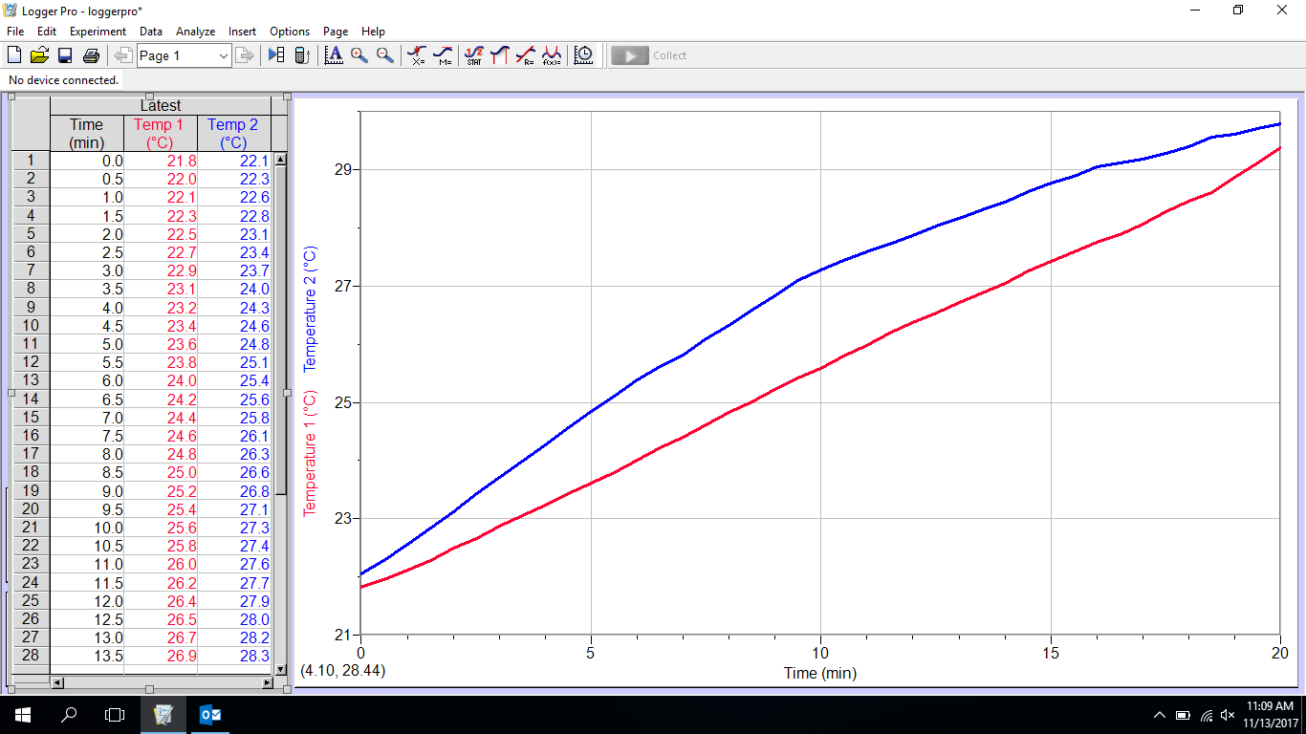P2

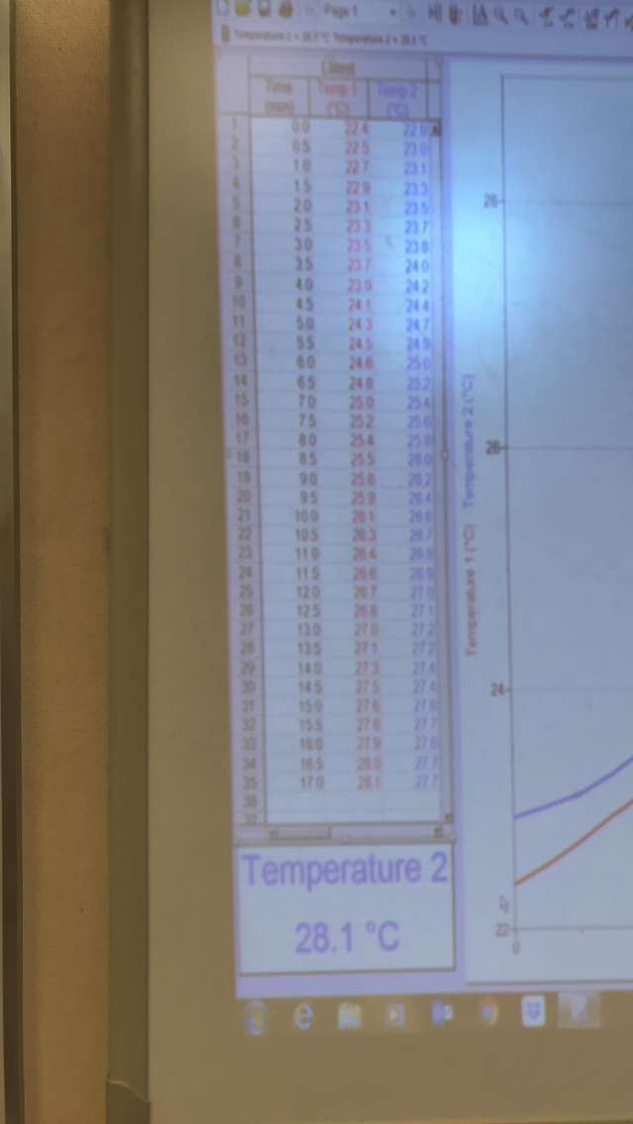P5

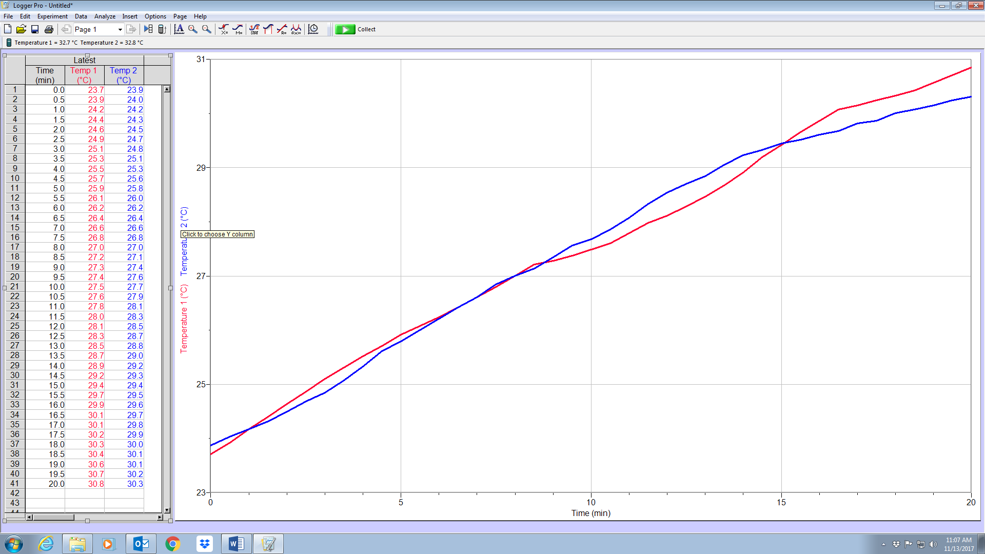P3

P6

