DNA to RNA to Protein Practice

Note Review Questions: Answer these before starting the video and working through the practice problems with Ms. Grant. She will not cover these in the video: instead the answers will be posted in the key on Thursday.
- What is a codon? What strand do you find a codon on?

- What is the goal of transcription (the first part of this process)?

- Where does transcription occur within the cell?

- What is the goal of translation (the second part of this process)?

- Where does translation occur within the cell?

- When Amino Acids are strung together and folded, what do they become?

Guided Practice: Ms. Grant will work through this in the video
Review: DNA DNA
Here is one half of a DNA strand. Complete the other half by writing the complementary base pairs.
T-A-C-G-G-T-A-T-A-C-C-C-A-T-T

Transcription: DNA RNA
This time use that same DNA strand to create a strand of mRNA.
T-A-C-G-G-T-A-T-A-C-C-C-A-T-T

Translation: RNA Amino Acid Chain
Use your codon chart to write down the correct amino acid sequence from the mRNA strand you created.

Practice Problems: Ms. Grant will work through the first one of these in the video: the rest will be posted in the key.
- DNA: CAT CCA ACC ATA CCC CTA TAC CCA TAT CCT CCC ATT AAA CCG
mRNA:
Amino Acid:

- DNA: AGATAA AGA CCA GCA ACA TAATAC CTC TTA ACA CTC CTC CGA TGA ACT
mRNA:
Amino Acid:

- DNA: TACCTTGGGGAATATCTTCGATGAATCCGTACACGCTGGACGGTACTCGCC ATC
mRNA:
Amino Acid:

- DNA: TAA ACT CGG TAC TAG ATC TAA CTA GCT TTA CCC ATC
mRNA:
Amino Acid:

What would happen to the protein above if the sequence of DNA changed by one base? Provide an example of how the protein would change using the above strand.

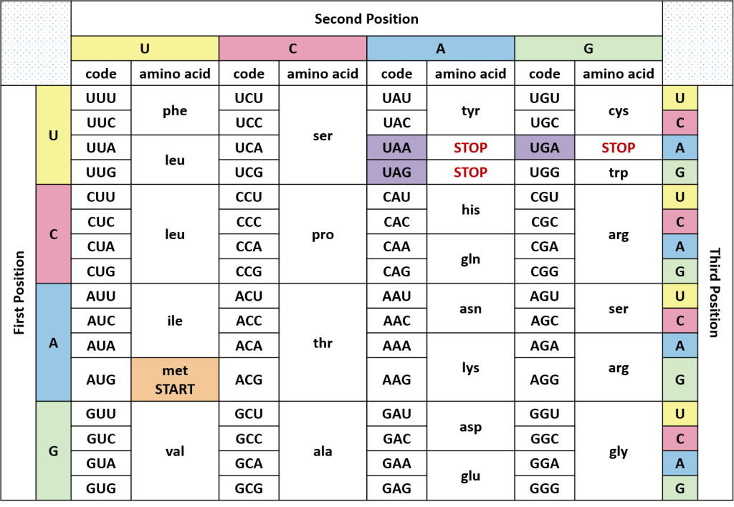
Codon Chart: Read the mRNA Codon (1st letter, 2nd letter, 3rd letter) to find the Amino Acid

