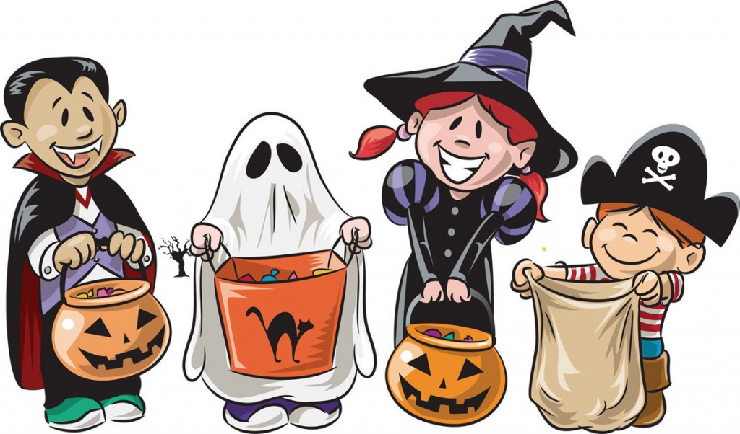
Ecology Quiz Review
Use the picture to the right to answer the following questions:

- What are 3 things you can infer from this picture?
- Inference 1:
- Inference 2:
- Inference 3:
- What are 3 things you can observe in this picture?
- Observation 1:
- Observation 2:
- Observation 3:
Think of the skyline outdoor lab. What are somethings in the skyline outdoor lab which are abiotic and which are biotic?

- Abiotic:
  - ______________________________________________________________
  - ______________________________________________________________
  - ______________________________________________________________
- Biotic:
  - ______________________________________________________________
  - ______________________________________________________________
  - ______________________________________________________________
- Use the following feeding relationships to create a food web below. (4pts)
- Write the name of each organism only: do not draw
- Include arrows to show all feeding relationships
Feeding relationships
- The cedar trees, snow berries and the vine maples get their energy from the sun
- The Blue Jay gets their energy from the snow berries.
- The squirrels get their energy from the seeds of the cedar, snowberries, and maples
- The bark beetle (insects) get their energy from wood of the cedar trees
- The woodpeckers and voles get their energy from insects
- The weasels get their energy from small mammals
- The owls get their energy from squirrels, voles and blue jays
- The earth worms get their energy from the dung of all other creatures

In the food web on the previous page, which organisms are producers, consumers, and decomposers?
- Producers: __________________________________________________________
_____________________________________________________________________
- Primary Consumers: ___________________________________________________
_____________________________________________________________________

- Secondary Consumers: _________________________________________________
_____________________________________________________________________

- Tertiary Consumers: ___________________________________________________
_____________________________________________________________________

- Decomposers: ________________________________________________________

- Use the food web to create a food chain.
Be sure to include:
- At least 4 organisms and the sun
- Energy arrows, going the correct direction
- The proper labels for each organisim

- Draw a monoculture and a biodiverse ecosystem in the boxes below.
  - Don’t worry about drawing skills, just label all organisims!
Monoculture | Biodiversity
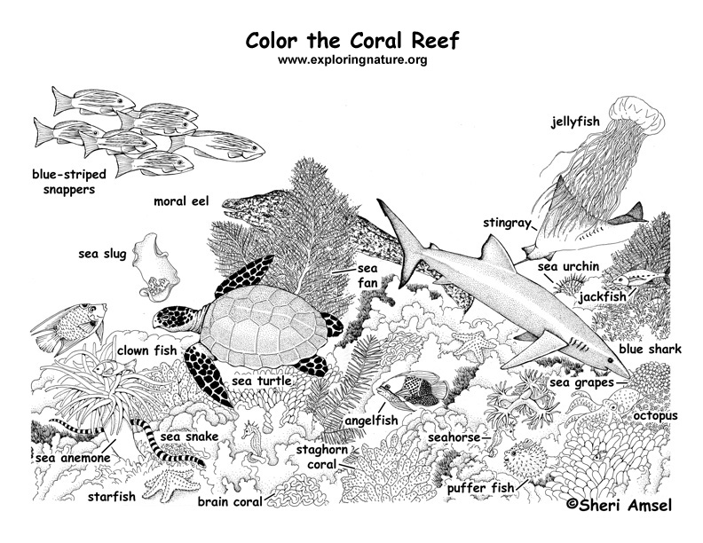
- Use the picture to complete the diagram below

- Vocabulary: On the next page of your journal, create a list of all the vocab we have talked about. Hint: we highlighted it!!

