Ecology Vocab Practice
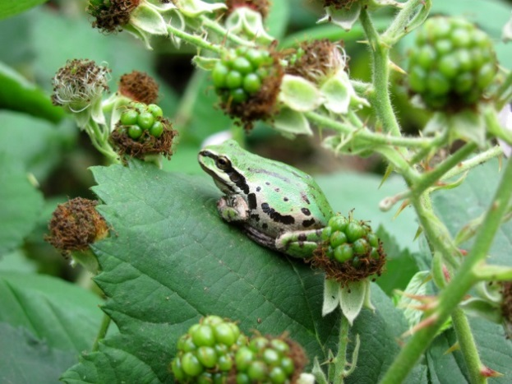
Use the pictures on the slides to answer the following questions. Use educated guesses!
Picture #1: Pacific Tree Frog in Blackberry Bush
- Describe the Ecosystem of the Pacific Tree Frog
  - What biotic factors could this little guy come in contact with?

  - What abiotic factors could he come in contact with?

- Describe the Environment of Pacific Tree Frog
  - Name at least 3 components of his environment. Think big!

- What does the Pacific Tree Frog need in his Habitat?
  - Name at least 3 things he needs!

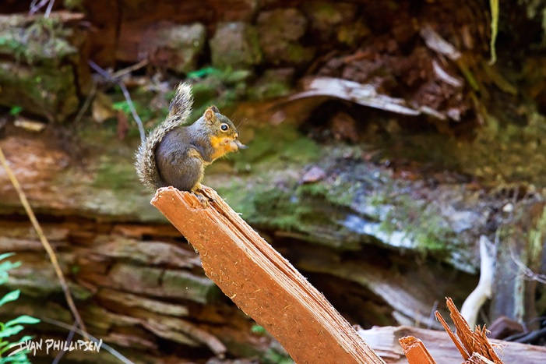
Picture #2: Douglas’s Squirrel in a Douglas Fir Forest
- Describe the Ecosystem of the Douglas’s Squirrel
  - What biotic factors could this little guy come in contact with?

  - What abiotic factors could he come in contact with?

- Describe the Environment of Douglas’s Squirrel
  - Name at least 3 components of his environment. Think big!

- What does the Douglas’s Squirrel need in his Habitat?
  - Name at least 3 things he needs!

