Enzyme Action Lab
Part 1: Lactose under normal circumstances
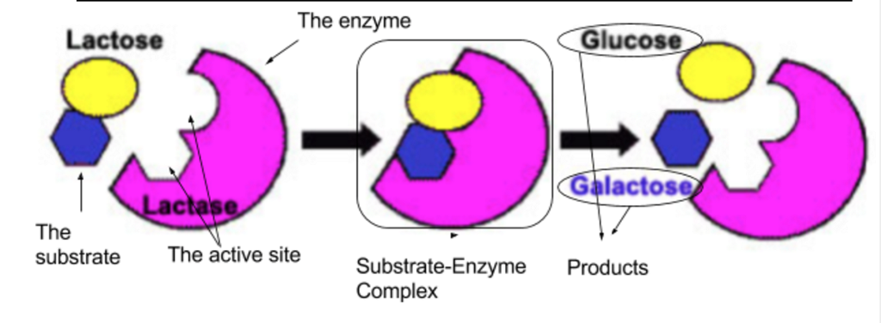
Objectives:
- Understand how the sugar lactose reacts in the presence of the enzyme lactase and
- Test how certain environmental conditions might affect the enzyme’s function.
- Present experimental findings to peers at a poster session

Background:
Lactose is the disaccharide (sugar) in milk that makes it sweet. Some humans produce the enzyme lactase that breaks lactose down into the monosaccharides: glucose and galactose. Infants and some (mostly European) adult humans produce lactase in their digestive systems. Humans who do not produce lactase are called ‘lactose intolerant,’ and cannot digest lactose. They often have symptoms characteristic of lactose intolerance (bloating, cramps, diarrhea) if they eat dairy products.

Glucose test strips detect how much glucose is in a solution, and are commonly used to measure how well the lactase enzyme is working. Milk that hasn’t been exposed to lactase only contains lactose, and no glucose. When Milk has been exposed to lactase, some of the lactose is broken down into detectable glucose. The faster the lactase enzyme is working, the more glucose will be in solution.

Food supplements such as Lactaid contain the enzyme lactase and help lactose intolerant people properly digest dairy products.

Pre-lab Questions: answer in complete sentences
- What is a disaccharide? (refer to notes from carbohydrates!)

- What two monosaccharaides make up lactose?

- What is the enzyme in this lab? How many amino-acids make up this enzyme (do research online)?

- What is the substrate in this lab? What kind of biological molecule is it? Where the substrate is naturally found?

Problem Question: How does glucose production differ in milk exposed to lactase versus milk not exposed to lactase?

Hypothesis: Use if…than…because format, and be sure to mention the manipulated and responding variables
________________________________________________________________________________________________________________________________________________________________________________________________________________________________________________________________________
Variables: If you have trouble, read through the procedure on the next page
Manipulated: _________________________________________________________________________________________________________
Responding: __________________________________________________________________________________________________________
Control:
- _________________________________________________________________________________________________________________
- _________________________________________________________________________________________________________________
- _________________________________________________________________________________________________________________

Groups: If you have trouble, read through the procedure on the next page
Experimental: ________________________________________________________________________________________________________
Control: _______________________________________________________________________________________________________________
Diagram of Procedure: Draw a Diagram of the Procedure (must include all materials as they would be setup)

Materials:
- Two test tubes
- Lactaid tablets
- Mortar and Pestle
- Water
- Tape and marker
- Glucose Test Strips
- Thermometer
- Pipette

Procedure: Highlight or underline an example of a step that prevents contamination
- Place two test tubes test tube racks.
- Grind up one Lactaid tablet in a mortar and pestle
- Use tape and a marker to label test tubes: #1 (milk and lactase) and #2 (control)
- Add 4 ml of room temperature whole milk to each test tube.
- Create a data table that will record temperature (ºC) and glucose readings (in mg/dl) for test tubes #1 and #2 (include all the rules for making a data table).
- Take the temperature of the milk initially and record.
- Rinse both thermometers between uses.
- Take a baseline reading of glucose concentration in test tubes #1 and #2 at Time 0 by adding a drop of liquid from each tube to a glucose detection strip. Wait 30 seconds, and then compare the color of the strip to the chart with the glucose detection kit.
- Record your readings in milligrams per deciliter (mg/dl)
- Use a piece of folded paper to add half of the Lactaid tablet to Tube 1. Swirl the mixture to be sure it is mixed well.
- Take glucose and temperature measurements every 5 minutes for another 15 minutes and record your glucose readings.
Data Collection:

Time (in minutes) | Glucose Concentration
 | Tube 1 (milk & lactase) | Tube 2 (milk)
0

5

10

15

-Stop Here to complete the prelab-
Data Analysis: Create a line graph that compares glucose production in both test-tubes. You should have two lines (use different colors with a key for each line) with 4 data points each. You will want to figure out the rate of the reaction producing glucose for each test-tube. Include these on the graph.

Analysis Question: Answer these on the next page in your journal
- Do some research online to find the optimum temperature and pH for lactase. What ranges of temperature and pH will lactase still work under?
- List a new problem question that your results bring up and that you would like to test next.

