Enzyme Action Lab
Part 2: Lactose under experimental circumstances
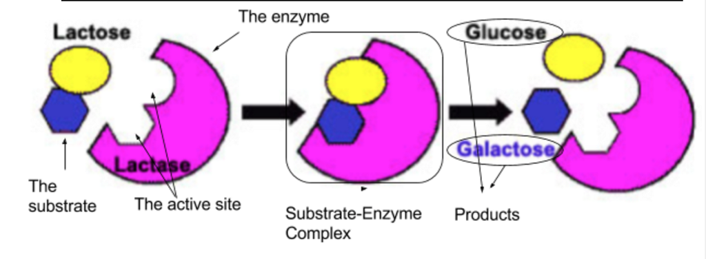
Objectives:
- Understand how the sugar lactose reacts in the presence of the enzyme lactase and
- Test how certain environmental conditions might affect the enzyme’s function.
- Present experimental findings to peers at a poster session
Background:
Lactose is the disaccharide (sugar) in milk that makes it sweet. Some humans produce the enzyme lactase that breaks lactose down into the monosaccharides: glucose and galactose. Infants and some (mostly European) adult humans produce lactase in their digestive systems. Humans who do not produce lactase are called ‘lactose intolerant,’ and cannot digest lactose. They often have symptoms characteristic of lactose intolerance (bloating, cramps, diarrhea) if they eat dairy products.

Glucose test strips detect how much glucose is in a solution, and are commonly used to measure how well the lactase enzyme is working. Milk that hasn’t been exposed to lactase only contains lactose, and no glucose. When Milk has been exposed to lactase, some of the lactose is broken down into detectable glucose. The faster the lactase enzyme is working, the more glucose will be in solution.

Food supplements such as Lactaid contain the enzyme lactase and help lactose intolerant people properly digest dairy products.

Now is your chance to test the follow up question you ended part 1 with! Your goal is to test one factor that can influence the rate of glucose production, in the presence of the enzyme lactase.

Day 1 &2: Experimental Design
Procedure:
- On your own, complete the Experimental Design Factor Chart, and write two investigative questions
- With your group, decide on two possible factors (you could use any one from your group!) and complete the Graphic Organizer.
  - Make sure each member has a copy! You could even actually copy it
- Choose a factor and a question to test!
  - Brainstorm materials you will need
  - You will need to get your problem question and materials needed checked off by your teacher before the end of the period tomorrow
- Write up one lab packet per group
  - This does need to be typed!
  - Complete as much as you can in class, as a group
  - If needed, students can take pieces of the write up home (e.g., diagrams or procedure) and complete them.
  - Author your work! If then entire group was present, you are all authors. If someone took it home, they are the author.

Reminders:
- Remember that you need 3 levels of manipulation and a control
- Remember that you are calculating rate- so you will want to use the same times as part 1 (0, 5, 10, 15 mins).
- To save expensive glucose test strips, we will limit our experiment to only 1 trial per manipulation.
- You should be using 12 glucose test strips total.
- You should still be measuring temperature as a control variable unless you are manipulating temperature as part of your experiment.

Lab Template:
PRE-LAB PACKET
Each group will turn in a copy of their prelab at the end of the experiment.
Title, name, date, partners
Page 1 – Investigative question, hypothesis, variables, groups, manipulations, list of materials
Page 2 – Draw and label a diagram of your experimental set-up
Page 3 – Procedure
Page 1: Page 2: Page 3:
Lactase Enzyme Experimental Design Lab
Your name
Date
Period

Investigative Question:

Hypothesis:

Variables:
Manipulated Variable:
Responding Variable:
Controlled Variables: 1-
2-
Groups:
Control:
Experimental:

Manipulations: 1.
2.
3.

Materials:

Experimental Setup:

Control Group:

Manipulation 1

Manipulation 2

Manipulation 3

Procedure:

- Ect…

Day 3: Testing
Procedure:
- Be prepared!
  - You will only have one day. Make sure to bring all materials not provided by Ms. Grant!
- Set up experiment
  - Make sure to label and avoid contamination!
- Run Experiment
  - Make sure you have a data recorder, and that they are accurate!
- Assign Roles for Poster
  - Make sure everyone knows their job before the end of the day!

Day 4: Poster Work Day
Procedure
- Divide up the sections of the poster (based on the template below) and complete as much as you can in class
- Each member will contribute ¼ of the total grade
  - No matter how many parts of the poster you create, your score will contribute 25% of the grade
  - If you can only do a few pieces well, that is better than doing many pieces poorly
  - There is no incentive for doing the entire poster yourself!
- Your poster should look professional
  - All writing typed, in an easily read and professional font
  - All graphs and tables either typed (excel or other program) or written in ink
  - All lines with a straight edge
  - All cutting and pasting neat
  - Clear, intentionally colored pictures and graphs

Lab Template:
POSTER
Introduction
Hypothesis and Variables
Methods:

Results
Diagram of Setup
Conclusion
Title
Authors names

Poster Sections and requirements:
- Introduction
  - Summary of your experiment
  - One paragraph long, including investigative question and answer
- Variables and Groups
  - All variables and groups from your experiment
  - Hint: these are in your pre-lab!
- Methods
  - Similar to procedure: number steps of what you did
  - What you did, not what you planned to do. Make any changes to your procedure!
- Results
  - All relevant data tables
  - All graphs
  - Include a key, axis labeled and a proper title for each
- Diagram of Set-up
  - Include all manipulations
  - Draw/diagram what you did, not what you planned to do
- Conclusion
  - One paragraph for Claim, Evidence, Reasoning
    - Answer the investigative question or state whether the hypothesis was supported or refuted
    - State evidence (highest data and lowest data)
    - State why that evidence supports the claim
    - Provide scientific reason for your results
  - Ask a question that could drive a new experiment
  - State errors in your lab

Day 5: Poster Presentation

Pier Viewing: Posters will be displayed around the room, and students will view each other’s work. Students will each have a viewing sheet, asking them to answer some simple questions about each poster. Your classmates should be able to answer fundamental questions about your experiment from your poster alone, so you don’t have to be present!

Presenting to Ms. Grant: Each group will sign up for a time slot to present their poster to Ms. Grant. At that time, all group members must be present at the poster, and prepared to answer questions about every section of the poster. Ms. Grant could ask any group member about any section, and that member must be able to answer.
- Make sure you understand all parts of the poster, not just those you wrote
- Each group gets one chance for a member to “phone a friend” during the presentation. This means that once during the entire presentation a student can ask another group member for help without losing points.

