Enzyme Action Lab
Part 2: Lactose under experimental circumstances
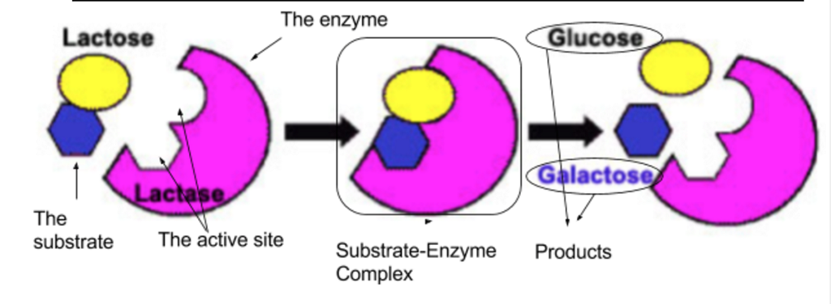
Objectives:
- Understand how the sugar lactose reacts in the presence of the enzyme lactase and
- Test how certain environmental conditions might affect the enzyme’s function.
- Present experimental findings to peers at a poster session
Background:
Lactose is the disaccharide (sugar) in milk that makes it sweet. Some humans produce the enzyme lactase that breaks lactose down into the monosaccharides: glucose and galactose. Infants and some (mostly European) adult humans produce lactase in their digestive systems. Humans who do not produce lactase are called ‘lactose intolerant,’ and cannot digest lactose. They often have symptoms characteristic of lactose intolerance (bloating, cramps, diarrhea) if they eat dairy products.

Glucose test strips detect how much glucose is in a solution, and are commonly used to measure how well the lactase enzyme is working. Milk that hasn’t been exposed to lactase only contains lactose, and no glucose. When Milk has been exposed to lactase, some of the lactose is broken down into detectable glucose. The faster the lactase enzyme is working, the more glucose will be in solution.

Food supplements such as Lactaid contain the enzyme lactase and help lactose intolerant people properly digest dairy products.

Now is your chance to test the follow up question you ended part 1 with! Your goal is to test one factor that can influence the rate of glucose production, in the presence of the enzyme lactase.

Day 1: Experimental Design
Procedure:
- On your own, complete the Experimental Design Factor Chart, and write two investigative questions
- With your partner, decide on two possible factors (you could use any one from your group!) and complete the Graphic Organizer.
  - Make sure each you both have a copy! You could even actually copy it
- Choose a factor and a question to test!
  - Brainstorm materials you will need
  - You will need to get your problem question and materials needed checked off by your teacher before the end of the period tomorrow
- Complete one lab template per pair
  - This does need to be typed: Just fill in the blank!
  - Complete as much as you can in class, together
  - If needed, you may take pieces home and attached them to the template when finished
  - You will be graded as a pair! However, please initial next to any part you author. If you contribute significantly less then your partner, you grade will suffer

Reminders:
- Remember that you need 3 levels of manipulation and a control
- Remember that you are calculating rate- so you will want to use the same times as part 1 (0, 5, 10, 15 mins).
- To save expensive glucose test strips, we will limit our experiment to only 1 trial per manipulation.
- You should be using 12 glucose test strips total.
- You should still be measuring temperature as a control variable unless you are manipulating temperature as part of your experiment.

Day 2: Testing
Procedure:
- Be prepared!
  - You will only have one day. Make sure to bring all materials not provided by Ms. Grant!
- Set up experiment
  - Make sure to label and avoid contamination!
- Run Experiment
  - Make sure you have a data recorder, and that they are accurate!
- Assign Roles for Poster
  - Make sure everyone knows their job before the end of the day!

Day 3: Poster Work Day
Procedure
- Divide up the sections of the poster (based on the template below) and complete as much as you can in class

- Your poster should look professional
  - All writing typed, in an easily read and professional font
  - All graphs and tables either typed (excel or other program)
  - All lines with a straight edge
  - All cutting and pasting neat
  - Clear, intentionally colored pictures and graphs
- You will be graded on what you contribute
  - Poster is worth 24 pts total
  - Each student is graded out of 12: you decide how to earn those 12 points, based on what you choose to author
  - The poster will also receive a “professionalism” score out of 5: this will be added to your personal contribution score

Lab Template:
MINI POSTER Below is a suggestion for a poster layout.
Introduction
Hypothesis and Variables
Methods:

Results
Diagram of Setup
Conclusion
Title
Authors names

Poster Sections and requirements: All should be TYPED, and neatly glued onto an 11x17 paper
- Introduction (2pts)
  - Summary of your experiment
  - One paragraph long, including investigative question and answer

- Variables and Groups (3pts)
  - All variables and groups from your experiment
  - Hint: these are in your pre-lab!

- Methods (6pts)
  - As a paragraph, describe what you did.
  - This is not the procedure: do not write numbered steps!
  - What you did, not what you planned to do. Describe any setbacks, changes, or mistakes!
- Results (Data Table: 3pts) (Graph: 3pts)
  - Data table: glucose production over time, temperature (if relevant) over time
    - Follow the Data Table Notes, be sure to include a title!
  - Graph of all data: Glucose production over time for all three manipulations and control
    - Include a title, key, axis labels
    - Should be a line graph, CREATED ON A COMPUTER

- Diagram of Set-up (1pt)
  - Include all manipulations
  - Draw/diagram what you did, not what you planned to do
    - Hint: TAKE PHOTOS!!!
- Conclusion (6pts)
  - One paragraph for Claim, Evidence, Reasoning
    - Answer the investigative question or state whether the hypothesis was supported or refuted
    - State evidence (highest data and lowest data)
    - State why that evidence supports the claim
    - Provide scientific reason for your results
  - Ask a question that could drive a new experiment

