EOC Conclusion Practice

Purpose:

Using your Conclusion Writing Notes, the EOC Rubric in your journal, and the data on the following page, give this student a score out of 5 for their conclusion

Re-write the conclusion correctly, aiming for a perfect score!

Introduction:

Below is a student response to an EOC conclusion prompt. All the data and information this student used to write this conclusion is on the backside of this page. You will be grading this student’s work, and then re-writing the conclusion for a perfect EOC Conclusion Score

Student Conclusion:
4 Write a conclusion for this controlled experiment.
In your conclusion, be sure to:
- Answer the experimental question.
- Include supporting data from the Acidity of Potato Juice vs. Volume of Foam table.
- Explain how these data support your conclusion.
- Provide a scientific explanation for the trend in the data.

Question: What is the effect of the acidity of potato juice on the volume of foam produced when
hydrogen peroxide is added to potato juice?
Ph8 has the most foam at 42. The more Ph does not mean the more foam, but the least Ph does mean the least foam. When the Ph
got to 8 it went down again at ph9. Ph7 is higher that Ph9. Ph9 is higher that Ph6. Ph8 caused the most foam than any other.

Directions:

Copy this table into your journals:
Attribute | Score: (1 or 0)

Conclusive Statement

Highest Data

Lowest Data

Explanatory Language

Scientific Reasoning
Total: | /5

Using the Conclusion Rubric and notes in your journal, grade the student on each attribute. If an attribute is present, give the student a point. If it is not, mark it as 0. Add all the points up, and give them a score out of 5.

Be harsh!! Pretend you are the meanest, most particular grader ever.

Re-write the conclusion, following the same prompt as the student, but making sure the response would receive 5/5 points.

Use your notes and rubric!!

Foaming Spuds

Directions: Use the following information to write a conclusion.

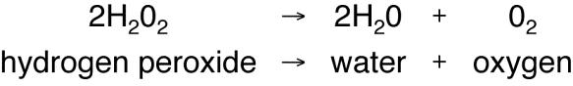
Mike and Kelsey were studying how hydrogen peroxide (H2O2) in cells breaks down to form water and oxygen. When this reaction happens, bubbles of oxygen gas are released, producing foam. This reaction is described as follows:

A protein named catalase, found in all cells including potatoes, increases the rate of this reaction. Mike and Kelsey used potato juice as the source of catalase to do the following controlled experiment.

Question: What is the effect of the acidity of potato juice on the volume of foam produced when hydrogen peroxide is added to potato juice?

Hypothesis: As the acidity of potato juice decreases (higher pH), the volume of foam will increase.
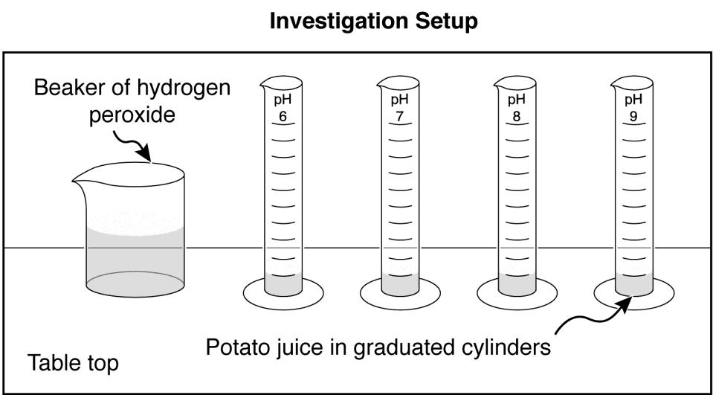
Controlled Experiment Setup

Materials:
graduated cylinders labeled pH 6, pH 7, pH 8, and pH 9 potato juice from the same potato, divided and adjusted to four acidities: pH 6, pH 7, pH 8, and pH 9 hydrogen peroxide (H2O2)
beaker stopwatch stirring rods thermometer

Procedure:
- Label four graduated cylinders, one for each acidity.
- Put 10 milliliters of potato juice at pH 6 in the appropriately labeled cylinder.
- Do the same for each of the other cylinders.
- Monitor the room temperature to make sure the temperature remains the same throughout the investigation.
- Add 5 milliliters of hydrogen peroxide to each graduated cylinder, stir for two seconds. Wait three minutes.
- Measure and record the volume of foam in each graduated cylinder as Trial 1.
- Clean all graduated cylinders and stirring rods.
- Repeat steps 1 through 7 two times for Trials 2 and 3.
- Calculate and record the average volume of foam for each acidity of potato juice.

Data:

Acidity of Potato Juice vs. Volume of Foam

Acidity of Potato Juice (pH) | Volume of Foam (milliliters)
 | Trial 1 | Trial 2 | Trial 3 | Average
6 | 22 | 25 | 25 | 24
7 | 32 | 38 | 36 | 35
8 | 41 | 42 | 42 | 42
9 | 32 | 29 | 30 | 30

- Write a conclusion for this controlled experiment.

In your conclusion, be sure to:
- Answer the experimental question.
- Include supporting data from the Acidity of Potato Juice vs. Volume of Foam table.
- Explain how these data support your conclusion.
- Provide a scientific explanation for the trend in the data.

