Lab Mendelian Genetics-Exploring Genetic Probability
CLASS
COPY
-Revisiting Mendel’s Observations

Part 2: Dihybrid Crosses
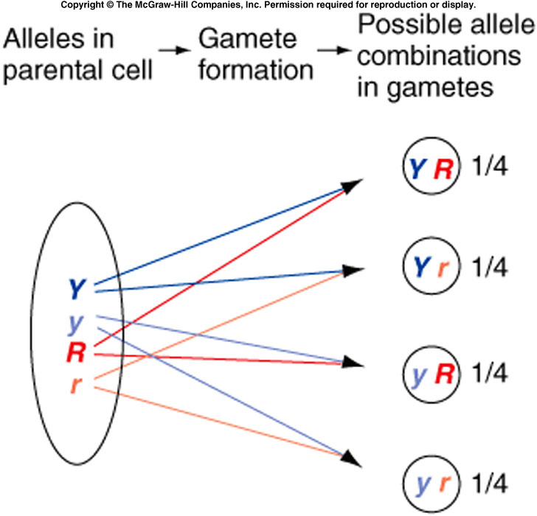
We will use four coins (two pennies and two nickels) to test the genotype and phenotype ratio which would result from a mating between parents who are heterozygous for each of two different traits. We call this a dihybrid cross. We will repeat the experiment in Part 1, this time completing 200 coin flips. Because we are looking at 2 traits, we will need different coins for each parent. One type of coin (penny) will represent one of the 2 traits contributed by the parent. The other type of coin (nickel) will represent the second trait contributed by that parent. There are 2 sides to each coin and 2 possible outcomes for each trait since each heterozygous parent carries 2 different alleles for each trait.

Do the results on the penny affect the results on the nickel? No, they flip independently from each other. In the same way, the genes for the two traits assort independently from each other into gametes. Mendel called this the “Law of Independent Assortment. “

Any 1 of 4 possible combinations may therefore turn up in any single gamete (sperm cell or egg cell). There are, therefore, 16 possible outcomes when the egg and sperm eventually meet.

Prelab Questions:
- Use your notes to explain the Law of Independent Assortment in your own words.
- In your booklet write down the possible gamete combinations for both the mother and father if both parents are heterozygous for brown eyes and heterozygous for the recessive trait for spinal muscular atrophy (SMA-a rare genetic disorder).
  - Copy the Punnett Square below into your journal and fill it out.
 |  | Mother (BbNn)
Father (BbNn) |  | BN | Bn | bN | bn
 | BN
 | Bn
 | bN
 | bn
B = brown eyes
b = blue eyes

N = normal Central Nervous System
n = Spinal Muscular Atrophy

a. What is the chance of having a child with blue eyes?

b. What are the odds of having a child with blue eyes and SMA?

c. What are the odds of having a child with brown eyes and SMA?

Investigation:
In Pea Plants,
- Rough seed shape (R) is dominant over smooth seed shape (r).
- Yellow seeds (Y) are dominant over white seeds (y).

Investigative Questions:
What is the effect of crossing 2 rough seed shape, yellow seeded heterozygous parents on the resulting genotypes of the offspring?

Hypothesis:
Write a hypothesis for the investigative question and use a Punnett Square and the genotypic ratios for this cross as the “because” part of the hypothesis. Mendel observed this outcome many times during his testing. The results were repeated with great precision.

Procedure:
- Determine the 4 possible gametes produced by either parent.
- Create a Punnett square to show the possible offspring from such a cross.
- Determine the possible seed shape and color of all offspring whose parents are each heterozygous for the two traits.
- Glue the data table into your lab notebook.
- The pennies will stand for the rough or smooth pods. Heads will be “R” and tails will be “r.”
- The nickles will stand for the yellow or green pods. Heads will be “Y” and tails will be “y.”
- Write the genotypes represented by each coin combination in the “genotype” column in the table.
- Write the phenotype produced by each genotype in the “phenotype” column of the table.
- From the outcomes in your Punnett Square, fill in the “expected probability” for each genotype. This is done by counting up the boxes in the Punnett Square that match each genotype. Remember that some of the alleles in your data table are produced in more than one way (ex. Heads-tails is the same as tails-heads). Then take the number of Punnett square boxes that match one genotype and divide by 16 to get the probability of that outcome. (Number of Squares for a Genotype/16 = Probability)
- Toss both coins 200 times.
- Record your results as appropriate hash-marks in the appropriate boxes under “Tally.”
- When finished, divide the results of each genotype (under “Tally”) by the total of tosses (200) to obtain the “Experimental Genotypic Outcome” and figure out the “Experimental Phenotypic Outcome.”

Conclusion: In a paragraph, answer the following questions. Use your Conclusion Rubric to help you!
- What conclusion do you draw from this experiment?
  - Answer the Investigative Question
  - Or, state whether the hypothesis was supporter/not supported, and restate the hypothesis.
- What data supports this conclusion?
  - Use numbers (either percentage or fractions) for each genotype
- How do those numbers prove your conclusion in #1?
  - Link the percentages you found to the ones you predicted!
- What is a scientific explanation for your findings?

Data Table B-Dihybrid Cross
Phenotype | Coin Combination |  |  |  | Tally | Expected Genotypic Probability | Experimental Genotypic Probability (outcome)
Rough, yellow seeds | PENNY HEADS | PENNY HEADS | NICKEL HEADS | NICKEL HEADS |  | 1 ÷ 16 = 0.0625 | (tally) ÷ 200 =
 | GENOTYPE(S)  RR only |  | GENOTYPE(S)  YY only
 | PENNY HEADS | PENNY HEADS | NICKEL HEADS | NICKEL TAILS
 | GENOTYPE(S)  RR only |  | GENOTYPE(S)  Yy or yY
 | PENNY HEADS | PENNY TAILS | NICKEL HEADS | NICKEL TAILS
 | GENOTYPE(S) |  | GENOTYPE(S)
 | PENNY HEADS | PENNY TAILS | NICKEL HEADS | NICKEL HEADS
 | GENOTYPE(S) |  | GENOTYPE(S)
 | PENNY HEADS | PENNY HEADS | NICKEL TAILS | NICKEL TAILS
 | GENOTYPE(S) |  | GENOTYPE(S)
 | PENNY HEADS | PENNY TAILS | NICKEL TAILS | NICKEL TAILS
 | GENOTYPE(S) |  | GENOTYPE(S)
 | PENNY TAILS | PENNY TAILS | NICKEL HEADS | NICKEL HEADS
 | GENOTYPE(S) |  | GENOTYPE(S)
 | PENNY TAILS | PENNY TAILS | NICKEL HEADS | NICKEL TAILS
 | GENOTYPE(S) |  | GENOTYPE(S)
 | PENNY TAILS | PENNY TAILS | NICKEL TAILS | NICKEL TAILS
 | GENOTYPE(S) |  | GENOTYPE(S)

