Lab Mendelian Genetics-Exploring Genetic Probability
CLASS COPY
-Revisiting Mendel’s Observations

Purpose:
Students will
- Learn that probability is strongly related to genetic outcomes.
- Determine whether probability supports or does not support the 19th century data and conclusions of Gregor Mendel.
- Be introduced to the probability of crossing two traits at a time, known as dihybrid crosses.

Vocabulary:

Gene
Allele
Trait
Gamete
Sperm
Egg
Heterozygous
Homozygous
Probability
Law of Segregation
Law of Independent Assortment
Monohybrid
Dihybrid
Zygote
Fertilization
Punnett Square

Background:
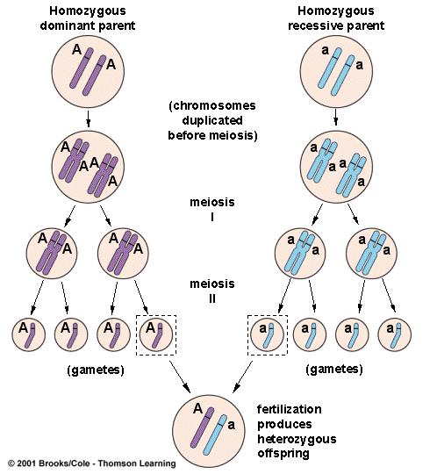
When a coin is tossed, it can only one land of two ways-either heads up or tails up. This is similar to when an organism makes gametes. Since an organism receives 2 alleles for a gene , one from the mother of the gamete maker and one from the father of the gamete maker, only one of these alleles will be transferred to a single gamete (sperm or egg)-not both.
If the gamete-making organism is a heterozygous (ex. Aa), the resulting gametes will either have the A (dominant) or the a (recessive) allele.
Mathematically, this situation is described as that the probability of getting one of the alleles (or side of the coin) over the other is 50%, 0.5, ½ or a 1:1 ratio. Mendal summarized this finding in his “Law of Segregation.”

Part 1: Monohybrid Crosses
In this Laboratory Activity, each side of a coin will represent an allele for a trait. Two coins will be tossed, one representing the allele in the sperm and one representing the allele in the egg. The results of flipping both coins will represent the resulting genotype of the zygote created by the union of the egg and sperm (fertilization). Remember that the zygote is the first somatic cell of a new organism. From this genotype, the phenotype can be determined.
The results of flipping these two coins will be used to mimic the genotypic and phenotypic outcomes recorded by Mendel for a single trait in a hybrid cross, specifically the mating of two heterozygous parents.
In pea-plant flowers, the color purple (P) is dominant over white (p). A heads-heads combination will represent a homozygous dominant outcome (purple flowers). A heads-tails combination will stand for a heterozygous outcome (purple flowers). A tails-tails combination will represent a homozygous-recessive outcome (white flower).
Materials:
2 Pennies

Investigative Questions:
What is the effect of crossing 2 purple-flowered heterozygous parents on the resulting genotypes of the offspring?

Hypothesis:
Write a hypothesis for the investigative question and use a Punnett Square and the genotypic ratios for this cross as the “because” part of the hypothesis. Mendel observed this outcome many times during his testing. The results were repeated with great precision.

Procedure:
- Glue the following data table into your journal.
- Label the top box in the left-most column of your data table with the phenotype that results from a PP genotype
- Label the second box in the left-most column of your data table with the phenotype that results from a Pp genotype.
- Label the third box in the left-most column of your data table with the phenotype that results from a pp genotype.
- Record the “expected probability” in the appropriate column of the table.
- Using 2 pennies, complete 100 simultaneous flips. Heads represents P and tails respresnts p
- Record your results as appropriate tally marks in the appropriate boxes under “Tally.”
- When you finish, divide the results of each genotype (under “Tally”) by the total of tosses (100) to obtain the “Experimental Outcome.”

Data Table A-Monohybrid Cross
Phenotype | Coin Combination |  | Tally | Expected Probability | Experimental Outcome
 | PENNY HEADS | PENNY HEADS
 | GENOTYPE(S)
 | PENNY HEADS | PENNY TAILS
 | GENOTYPE(S)
 | PENNY TAILS | PENNY TAILS
 | GENOTYPE(S)

Data Table A-Monohybrid Cross
Phenotype | Coin Combination |  | Tally | Expected Probability | Experimental Outcome
 | PENNY HEADS | PENNY HEADS
 | GENOTYPE(S)
 | PENNY HEADS | PENNY TAILS
 | GENOTYPE(S)
 | PENNY TAILS | PENNY TAILS
 | GENOTYPE(S)

