Genetics: How and Why
- Examine the drawings of horsefly chromosomes below. Complete the table by filling in the information about the chromosomes.
Body Cell | Sex Cell
 |  | Number of chromosomes present
 |  | Can the chromosomes be put in pairs?
 |  | Haploid or Diploid & how do you know?

- Genes are often shown as lines on chromosomes. Examine the diagrams below of a pair of body cell chromosomes and a sex cell chromosome of a horsefly. Complete the diagrams by drawing the genes on the unmarked chromosomes. Label them by trait.
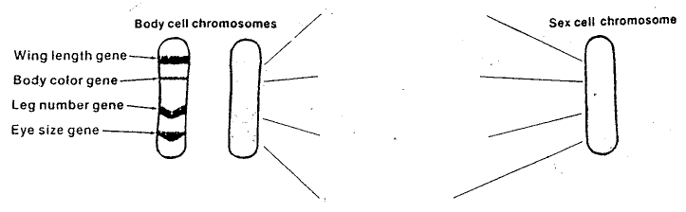
- How many genes for wing length are present in this body cell? __________________
- How many genes for wing length are present in this sex cell? ___________________
- In dogs, black fur is dominant to brown fur. What color will a dog be if it is:
- homozygous dominant? ________
- heterozygous? ________
- homozygous recessive? _________
Expected and Observed Results
- Here are six dogs. In the small box below each dog, use uppercase or lowercase letters to write the genes present in the body cells of that dog. Use “B” for black and “b” for brown.
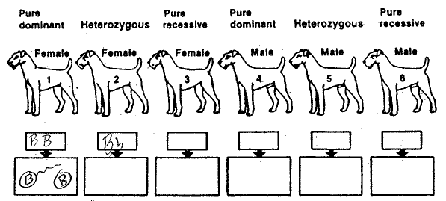In the large boxes, draw one possible combination of sperm and egg that would produce that genotype. Draw ovals for eggs, and ovals with tails for sperm.
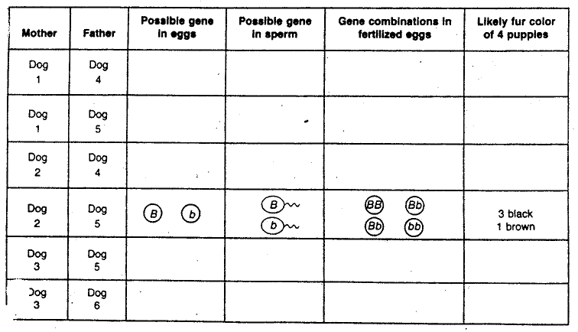
- The table below shows the possible results of mating the dogs. Complete the table.

