Gummy Bear Video Worksheet: Go to https://www.youtube.com/watch?v=K_QJMQUX6bo. Fill out the table below as you watch, then answer the question
 | Gummy bear in ____________________ | Gummy bear in ____________________ | Gummy bear in ____________________ | Gummy bear in ____________________
Draw which way liquid moved onto the diagram for each solution | 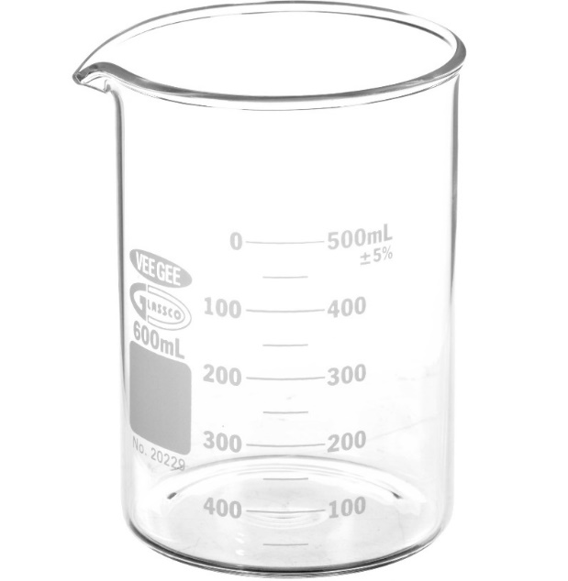  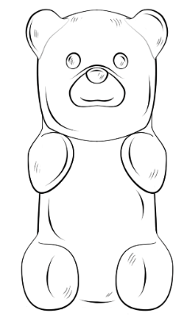
Describe what happened to the gummy bear.

Why did the liquid move the direction it did? Be sure to use “concentration gradient” in your anser

- Which solution had the most similar concentration to the inside of a gummy bear? How do you know?

