Evolution of Horses Activity
Purpose: To examine fossils and compare them to the present day horse. To determine if changes in horses have taken place over time.
Background: Horses, humans, and all other mammals share a common ancestor--with five toes. Over millions of years, the middle toe evolved into a single-toed large hoof, while the other toes became smaller and ultimately functionless. The remains of these tiny vestigial toes can still be found on the bones above their hoofs.
Two major changes in climate affected the evolution of early horses. First, about 55 million years ago, global temperatures abruptly rose, turning much of North America into a warm, wet, subtropical forest--much like today’s Brazilian Amazonian rain forest. Small, leaf-eating horses thrived. The Hyracotherium, the common ancestor of today’s horses, was a small forest animal that looked nothing like a horse. It resembled a dog with an arched back, short neck, short snout, short legs, and long tail. It grazed on fruit and soft foliage with its short teeth, and probably would have had mannerisms more like that of a deer (timid, flighty, etc.).
Then, about 35 million years ago, global temperatures dropped, and dry grasslands replaced much of the North American forest, leading to rapid evolution among horses. By about nine million years ago, most forest browsers had disappeared, leaving primarily grass-eating grazers like those alive today. The modern horse, Equus has a classic “horsey” body – rigid spine, long neck, legs, and nose, and fused leg bones with no rotation. This species has long, straight, grazing teeth good for grinding.
Single-toed hooves and long, sturdy, light-weight legs help a horse run farther and faster on the open prairie. This helps them find fresh grass for grazing and flee from predators, a useful trait on the open prairie, where there's no place to hide. In the forest, where the ground is softer, many horses retained three toes.
Short teeth are fine if you're grazing on soft leaves, like the Hyracotherium shown eating in the forest. But grazing on tough grasses would quickly wear short teeth down to nothing. For prairie horses evolution favored longer teeth that could handle the grind of grazing--as a tooth wears down, more emerges.
http://www.amnh.org/exhibitions/horse/the-evolution-of-horses
http://netnebraska.org/basic-page/television/wild-horses-evolution-timeline

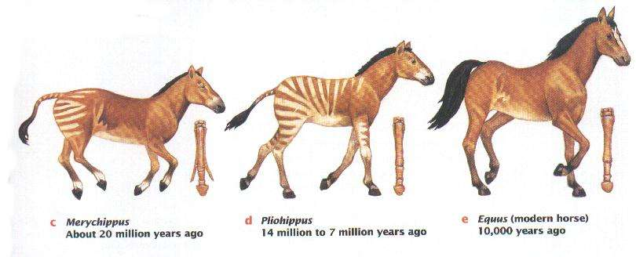
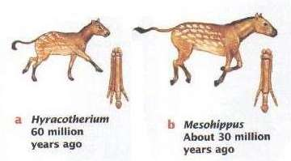

Data & Observations
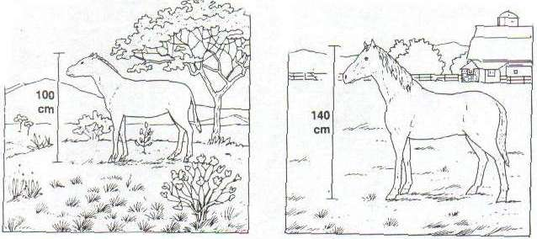
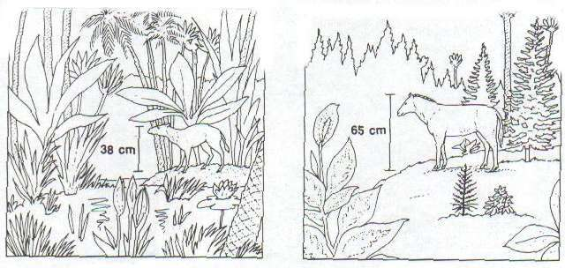
Figure 1: Climate Change
Hyracotherium | Miohippus | Merychippus | Equus
65 million years ago | 30 million years ago | 13 million years ago | Today
Figure 2: Fossil Bone Structure
Examine the fossils of bone structure and teeth for each species. Bone structure and teeth can be used to determine how each animal was adapted for its environment and the type of food it ate.
- The bones in the following diagrams show fossils of the front foot bones and teeth of each species. The foot bones at the upper right of each diagram indicate the relative sizes of each species.
- Using the diagrams in Figure 2, make measurements to fill in Table 2.
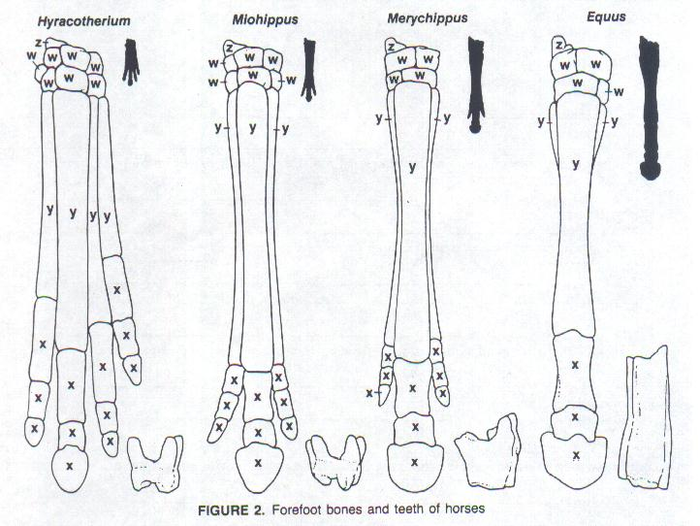

Evolution of Horses Activity :
Data/Observations:
Part A: Examine the pictures in Figure 1 and read the background section. Use the pictures and information to fill in Table 1.
Table 1
 | Hyracotherium | Miohippus | Merychippus | Equus
Size (cm)
Type of Environment

Part B: Using the diagrams in Figure 2, make measurements to fill in Table 2.
Table 2
Species | Hyracotherium | Miohippus | Merychippus | Equus
Number of toes
Number of toe bones (marked with x)
Total number of bones
Length of foot (cm) - measure Figure 2 outlines, ankle to toe
Height of teeth (cm)
Questions: Answer questions #’s 1 – 8 in your journal.
- What changes occurred in the surroundings of the species from Hyracotherium to Equus?
- What change occurred in the shape of each species from Hyracotherium to Equus?
- What change occurred in the size of each species from Hyracotherium to Equus?
- As the surroundings changed, what happened to the teeth of each species?
- Describe the overall changes in foot length, number of toes, and size of toes in each species over time.
- List two adaptations that modern horses have for surviving in the open grassy plains.
- Could natural selection have caused changes in the size, feet, and teeth of each species?
- What did you learn about fossil evidence related to change in species? Does this show evidence of evolution of the horse?

