Building Phospholipid Activity
In a group of 4-5, assemble the following structures below using the Molecular Model Kits.
- First you need to figure out which bead color corresponds to which element.
- Second, you need to figure out which are the single bonds and which are the double bonds.
- Once you have done that it is time to build your lipids.

Lipids are assembled by enzymes. Each group member will represent an enzyme:
- Enzyme #1 makes glycerol
- Enzyme #2 makes a phosphate group
- Enzyme # 3 makes a saturated fatty acid tail (hydrocarbon chain)
- Enzyme #4 makes an unsaturated fatty acid tail (hydrocarbon chain)

Create your small molecules:
- Choose an enzyme to represent, and use your notes to build your molecule.
  - Show Ms. Grant to make sure you have it correct
- Once all group members have built their molecules correctly, draw the chemical structure of each molecule into your journal
  - Be sure to label each molecule!!

Create a Phospholipid:
- Combine all 4 molecules to create a phospholipid
  - Hint: use your notes and your Lipid Cut & Paste activity as a guide!
  - Hint: You will have to remove some atoms to create your macromolecule
  - Show Ms. Grant to make sure you have the molecule correct
- Once you have correctly created a phospholipid, draw your molecule into your journal
  - Be sure to label your molecule!
  - Circle and label each small molecule that you started with as well!!
- Use the left over atoms to create a common molecule
  - Show Ms. Grant to make sure that you have created the correct molecules!
- Draw the molecule you have created, and label it!
- What is the name of the process you just modeled?

Break down a Phospholipid
- Break apart the phospholipid into the original 4 subunits
  - Hint: You will need the molecules you created in #5!
- Describe what you have to do to break down your phospholipid
  - Be sure to use and mention all molecules and elements!!
- What process did you just describe?

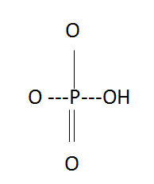
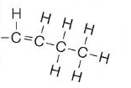
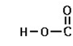
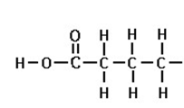
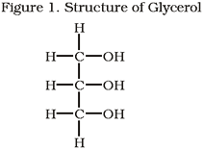
Figure 4: Structure of a Phosphate Group
Figure 3: Structure of an Unsaturated Fatty Acid
H
Figure 2. Structure of Saturated Fatty Acid Tail (make 3)

