Global warming is an environmental science topic of much concern. The average surface temperature the Earth increased by 0.6⁰C during the 20th century, with the increase occurring mainly from 1910 to 1945 and 1976 to 2000. The 1990s was the warmest decade, and 1998 was the warmest year of the century and on record. Growing scientific consensus attributes this global warming to the enhanced greenhouse effect. In this experiment you and your classmates will investigate the greenhouse effect and the enhanced greenhouse effect.

OBJECTIVE: To compare temperature change of heated ambient air and air infused with carbon dioxide.

PRE-LAB: Include all of the following in your Lab Write-up. This does not have to be in pen, simply a stapled packet with the rubric on top!. Please include the headings!

- MATERIALS: Include all materials needed for this experiment, in a bulleted list
- DIAGRAM OF SETUP: (Both the experimental and control group set up) Copy the diagram on the back of this sheet. Make this AT LEAST 1/2th page, and remember to add labels with quantities.

- PROCEDURE: Create a procedure for this experiment, based off of the diagram. Write this as a numbered list, and be sure to include all parts of a procedure! Check the “Procedure Do’s and Don’ts” poster for hints

- DATA TABLE TITLE: Create a data table for this experiment. Remember to include a title, column labels, and an average column!

LAB ANALYSIS: Include all of the following in your lab write-up after the lab demo is complete.
- GRAPH: Use graph paper, draw a best fit line and include a legend.
- ANALYSIS QUESTIONS: Answer the following questions in complete sentences.
  - In the experimental group what was the initial temperature? What was the final temperature?
  - Calculate the temperature change for the experimental group.
  - In the control group what was the initial temperature? What was the final temperature?
  - Calculate the temperature change for the control group.
  - Which gas retains the heat the most? Give quantitative evidence to support your answer.
  - Calculate the slope of the 2 lines. Show your work.
  - Compare the 2 slopes you calculated in #6. What are these slopes telling you about the temperature of the CO₂ and the ambient air?
  - How does these results relate to global warming and climate change?
- CONCLUSION: Discuss results of lab and include evidence from data table. List 2 errors and improvements
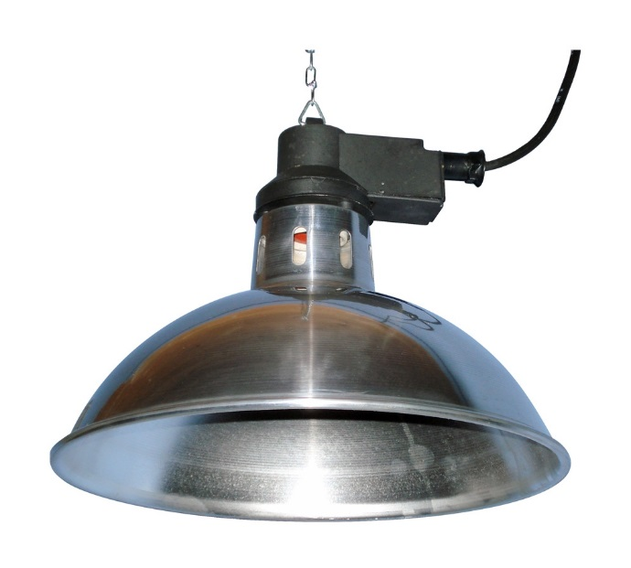
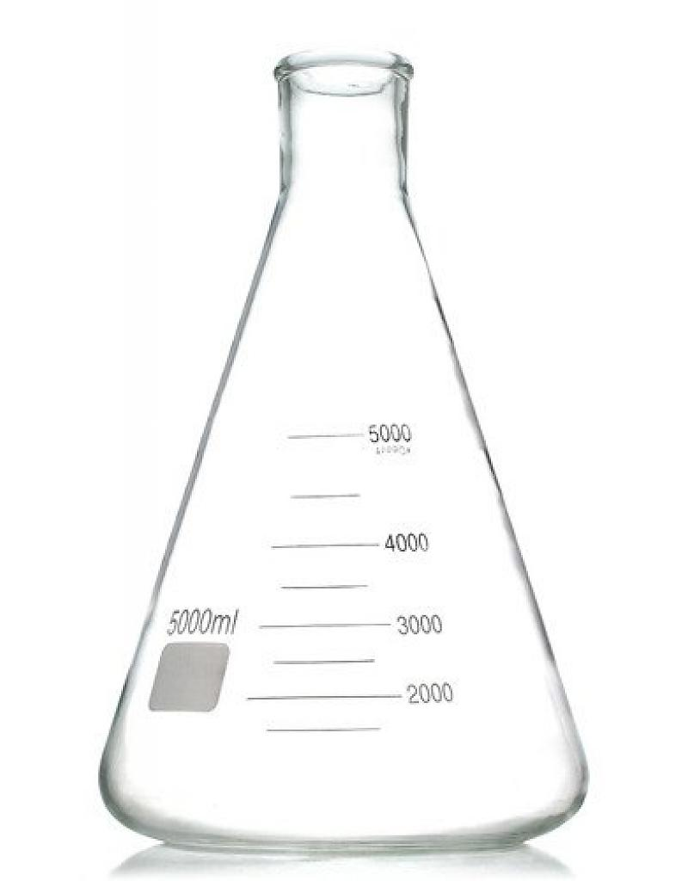
DIAGRAM OF SET-UP
Logger Pro Interface (connected to the computer)
Erlenmeyer Flask
(with CO₂ from bottle)
Rubber Hose
Rubber stopper & glass tube
Bakeing Soda + Vinegar
= CO₂
Heat lamps
Temperature Probe
Temperature Probe
Erlenmeyer Flask
(with ambient air)

