Exam Review: Microscopy, Cell History & Theory, Cell Structure and Function

Be able to answer the following questions, and explain the following concepts
This review is for you. I suggest answering all of these questions, and researching these topics, but I will not be collecting this. The note blank pages corresponding to each topic are in parenthesis.

Microscopy: (Review of Microscopy: page 9-11)
Be able to identify all the parts of a microscope
Be able to make a wet mount slide
Understand how to calculate Total Magnification
Be able to focus at 40X, 100X and 400X

Cell History & Theory (Cell Discovery & Cell Theory: page 23)
Who was Antony van Leeuwenhoke? What did he do, and when?
Who was Zacharias Jansen? What did he do and when?
Who was Robert Hooke? What did he do, and when?
Who was Mattias Schleiden? What did he do, and when?
Who was Theodor Schwann? What did he do, and when?
Who was Rudolf Vichow? What did he do, and when?
When was the modern microscope invented?
What is the difference between a light microscope and an electron microscope?
What is Cell Theory? Be able to state all 3 parts, and understand their meaning

Cell Structure and Function (Cell Structure and Function: page 24-29)
Be able to name all the major parts of a Prokaryotic cell, and describe their function
Describe the difference between prokaryotic and eukaryotic cells
Be able to name all the major parts of an animal cell, and describe their function
Be able to name all the major parts of a plant cell, and describe their function
Describe the major differences between plant and animal cells
What does unicellular mean?
What does multicellular mean?
Provide an example of a unicellular organism, and a multicellular organism.

Do the following activities, either in class during review, or at home
This is still for you. However, your brain learns best by studying new concepts in several ways! We will be working on some, but not all of these activities in class. It is suggested that you do all activities, and ask for clarification and corrections during class review time.

- Draw a time line of all the major moments in the creation of the microscope and the discovery of the cell.

1595 2015

- Label the microscope below from memory and check it from your notes.
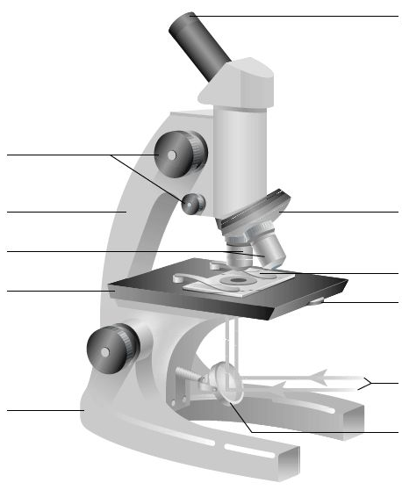

- Draw and Label both a plant and an animal cell from memory and check if from your notes.

Plant Cell Animal Cell

- Draw a Prokaryotic cell from memory and check it with your notes.

