Understanding Cancer
Use the resources provided in class and on the website to complete this worksheet.
Section 1: Factors Reported to Be Associated with Cancer
View the News Alert! videos with the class and use the information provided to identify what each video suggests is the cause of cancer and what evidence supports that claim.

News Alert/ Video | Factor Proposed to Cause Cancer | Evidence
Cancer and Chemical Poisons

Cancer and Your Family History

Cancer and Radiation Exposure

Cancer and UV Light

Section 2: Building an Explanation for the Cause of Cancer
View the Cell Cycle animations with the class. Think about the information each animation presents, then write a one-sentence statement for each that summarizes what you learned.

Animation 1
Cancer involves . . .

Animation 2
Cell division normally is . . .

Animation 3
Cell cycle regulation is accomplished by . . .

Animation 4
Cancer-causing agents often . . .

Animation 5
When damage occurs to genes that regulate the cell cycle . .

Section 3: Explaining Factors Associated with Cancer
Using your notes from Section 1, write a sentence describing how our current understanding of cancer explains the role that each factor plays in causing cancer.
Cancer and Chemical Poisons

Cancer and Your Family History

Cancer and Radiation Exposure

Cancer and UV Light

Colon Cancer Incidence by Age

Examine following graph, and use it to answer the questions below.

Incidence of Colon Cancer by Age

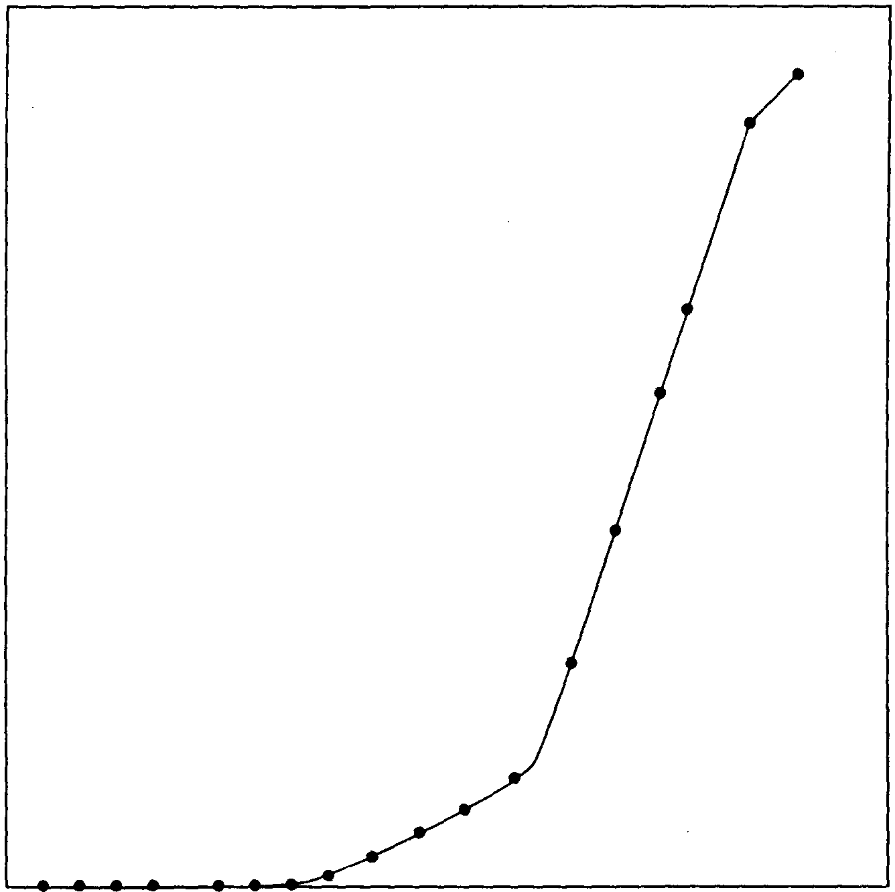
350
300
250
200
150
100
50
0
number of people (per 100,000)
0 20 40 60 80 100
age

- How likely is it that you will develop colon cancer this year?

2. How likely is it that someone who is 60 years old will develop colon cancer this year?

3. How likely is it that someone who is 80 years old will develop colon cancer this year?

4. How can we explain this change in the risk of a person developing colon cancer?

