Non-Disjunction Practice
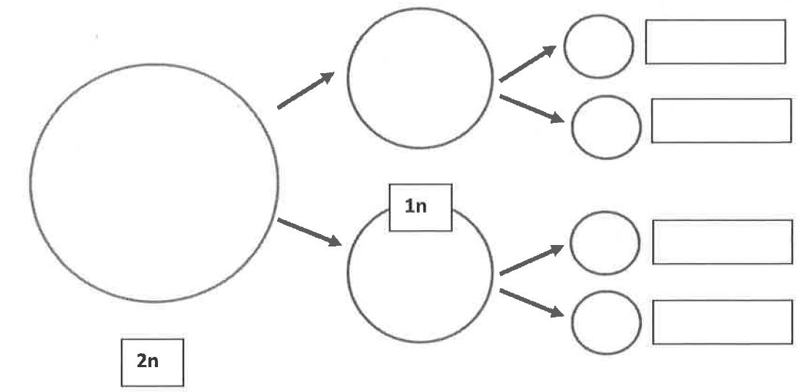
- Normal Meiosis: Fill in the cells below for a cell that has a n=3. Draw the chromosomes in Prophase I, Prophase II, and the final sperm, then write the n number for the resulting gametes. Be sure to include separate colors for mom’s chromosomes and dad’s.
- Meiosis with Non-disjunction I: Fill in the cells below for a cell that has a n=3. Draw the chromosomes in Prophase I, Prophase II, and the final sperm, then write the n number for the resulting gametes. Be sure to include separate colors for mom’s chromosomes and dad’s.
- Meiosis with Non-disjunction II: Fill in the cells below for a cell that has a n=3. Draw the chromosomes in Prophase I, Prophase II, and the final sperm, then write the n number for the resulting gametes. Be sure to include separate colors for mom’s chromosomes and dad’s.

