Background: A field experiment gives a more accurate picture of how organisms interact in a natural setting than in the artificial setting of a lab. However, it is more difficult to determine cause and effect due to the large number of factors at work in nature. A field experiment is performed where the organisms live. Like lab experiments, field experiments also have controls and manipulated variables.
Class Copy!!!
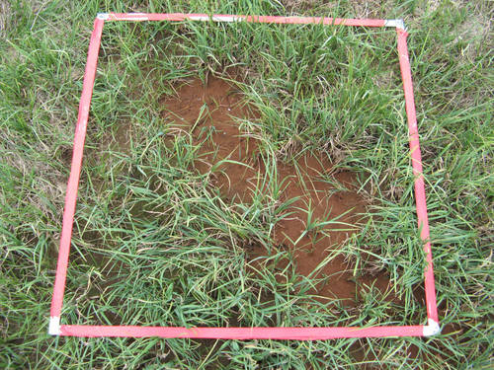
Ecologists often use quadrat sampling-square or rectangular frames-to collect data about population numbers in an ecosystem. These frames are randomly placed on the study site. To determine plant population numbers, scientists identify and count the number of plants with each randomly selected plot. The total number of counted plants is then plugged into a mathematical formula to determine the plant population of the entire study site. In this lab, you will use a quadrat to collect data on the number of a chosen species of plant in various areas.

3 study areas:
- Big (Mature) Forest -324 m²
  - Trees are large, and the foliage covers much of the sky
- Smaller (Younger)Tree Forest -513 m²
  - Trees are smaller, and foliage covers some of the sky
- Pond area (no trees)-284 m²
  - No trees

In your lab notebook, your will write up the following:
- Complete the pre-lab.
  - Answer the pre-lab questions
  - Identify and list variables
  - Identify and list groups
  - Write your hypothesis.
  - Write your experimental procedure.
  - Draw a diagram of the experimental set up.
- Write a data collection table (include columns for both quantitative and qualitative data).
- Draw a graph of your findings
- Answer the analysis questions
- Write a conclusion
Prelab: First, tour of the three locations. Choose a plant species to study and bring in a sample.
Questions:
- What kind of data will you be recording? Write a description of your chosen plant.
- Make a rubbing of your chosen plant specimen. (Turn your leaf/leaves over so the veins stick up. Place the paper over the specimen. Rub the paper over the specimen with the pencil lead at an angle.) KEEP THIS TO INCLUDE IN YOUR FORMAL LAB WRITE UP.
- Describe the 3 locations you will be observing. What characteristics do they have in common? How are they different?
- How can you make sure your results will be valid and reliable?

Experimental Design: Plan a field study to answer the investigative question. You will use the following materials and equipment in your procedure: random number chart, 1 quadrat (1 m²), 3 natural areas, 1 calculator.
Investigative Question: What is the effect of the amount of shade (increasing or decreasing) on the number of one type of plant?

Manipulated/Independent Variable:

Responding/Dependent Variable:

Controlled Variables:

Experimental Group:

Control Group:

Hypothesis:

Procedure:
Be sure your procedure includes:
- your manipulated, responding and control variables
- what data you will collect
- how you plan to collecting data
- how often measurements should be taken and recorded
- environmental conditions to
be recorded
- logical steps to do the field study

Diagram of Set Up:
Your diagram should:
- Include the 3 locations and all the materials used.
- Be at least half a page in total
- Be labeled with all relevant information.

Data Collection:

Quantitative data: a data table to record your data

Qualitative data: other information about each of the locations that can’t be written as numbers

Leaf/leaves rubbing:

A written description of characteristics of your chosen specimen:

Analysis:
Bar graph on Graph Paper:

Questions: Answer each of the following in complete sentences
1. Which of the three locations had more of your chosen plant species?
2. What characteristics of that area made it easier for that type of plant to survive?
3. Which of the characteristics listed in question #2 are considered non-living?
4. Which of these characteristics are considered living?
5. Calculate an estimated population density using the following formula.
- Include the general formula and the values you plug into the formula in your formal write up.
- You will need 3 calculations for each.

Estimated Population Density of Each Location = Avg Number of individuals/Area (units2)
Estimated Total Population of Each location= Estimated Population Density of Each Location x Total Area (m2)

Argumentation: Write a conclusion to sum up the findings of your lab

Depth and Development:
1. How would a change in season affect your species (example: more sun in winter due to leaf loss).
2. How would you find the population number for a mobile species?

