Ecological Biodiversity of the Skyline Outdoor Lab
Class Copy!!!
Background: A controlled experiment preformed outside a lab is called a field experiment. Field experiments more accurately show how organisms interact in a natural setting, but the variables are much harder to control. Often, there are many factors that could affect the manipulated variable, which are impossible to keep constant in the field.
One way that that ecologists determine the health of an ecosystem is by assessing biodiversity - the variety of different species in an ecosystem.

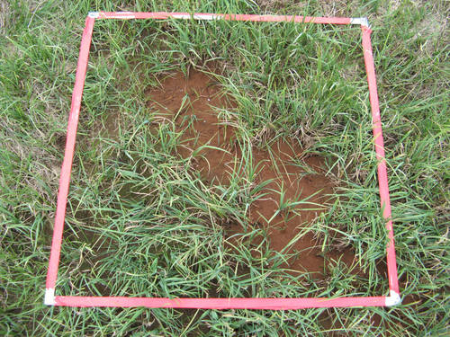
However, ecosystems are very large: it is impractical to try to list the number of each species throughout the entire ecosystem. Instead ecologists use a random sampling method (counting species in several randomly selected smaller areas) to measure biodiversity over several trials, and then take the average. The assumption is that number of different species in the average will be an accurate representation of the entire ecosystem.

Often the random sampling method includes a quadrat – a meter by meter square placed randomly on the ground.

3 study areas:
- Big (Mature) Forest -324 m²
  - Trees are large, and the foliage covers much of the sky
- Smaller (Younger)Tree Forest -513 m²
  - Trees are smaller, and foliage covers some of the sky
- Pond area (no trees)-284 m²
  - No trees

Prelab: Before you can begin an experiment, you must complete some background work, often called the prelab. This includes gathering background knowledge and spelling out the specifics of the experimental design.
First, Complete the following in your lab journal:
- Tour the three locations
  - Notice the variety of species in the area
  - Take notes on how to identify and differentiate different species
  - Tape in or make rubbings of samples to help you identify
- Answer the pre-lab questions
- Create a data collection table
  - Make sure you can record all your data!
Pre-lab Questions:
- What kind of data will you be recording?
- Describe the 3 locations you will be observing. What characteristics do they have in common? How are they different?
- What are some variables you should attempt to control in the environment?

Second, complete a rough draft of the experimental design on the online template, and share the link with Ms. Grant. This rough draft will include:
- Identify and list variables
- Identify and list groups
- Write your hypothesis.
- Write your experimental procedure.

Final Lab Write-Up: This is a formalized type of experiment design, and will always follow the same format, as explained in class and listed on Ms. Grant’s website.
For this Formal Lab Write-Up, include:
- A lab title, student name (circled), group member’s names, class period, and date
- Identify and list variables
- Identify and list groups
- Write your hypothesis.
- Write your experimental procedure.
- Draw a diagram of the experimental set up.
- Write a data collection table (include columns for both quantitative and qualitative data).
- Draw a graph of your findings
- Answer the analysis questions
- Write a conclusion
Below is an example of what your formal lab write up should look like. The page numbers are a suggestion only: if you need more pages, feel free to add them!
Page 1: Page 2: Page 3:
Lab Title
Your Name, Group Member 1, Group Member 2, Group Member 3
Date
Period

MV:
Rv:
2CVs:
Experimental Group:

Control Group:

Hypothesis:

Procedure:
1.
2.
3.
4.
Ect…

Diagram:

Location 1 Location 2

Location 3

Data Table:

Qualitative Data

Analysis Questions:

Conclusion:
Experimental Design: Plan a field study to answer the investigative question. You will use the following materials and equipment in your procedure: random number chart, 1 quadrat (1 m²), 3 natural areas, 1 calculator.
Investigative Question: What is the effect of the amount of shade (increasing or decreasing) on the number of one type of plant?

Manipulated/Independent Variable:

Responding/Dependent Variable:
Controlled Variables:

Experimental Group:

Control Group:

Hypothesis:

Procedure:
Be sure your procedure includes:
- your manipulated, responding and control variables
- what data you will collect
- how you plan to collecting data
- how often measurements should be taken and recorded
- environmental conditions to
be recorded
- logical steps to do the field study

Diagram of Set Up:
Your diagram should:
- Include the 3 locations and all the materials used.
- Be at least half a page in total
- Be labeled with all relevant information.

Data Collection:

Quantitative data: a data table to record your data

Qualitative data: other information about each of the locations that can’t be written as numbers

Analysis:
Bar graph on Graph Paper:

Questions: Answer each of the following in complete sentences
1. Which of the three locations had the highest biodiversity?
2. What characteristics of that area made it easier for many different species to survive?
3. Which of the characteristics listed in question #2 are considered non-living or abiotic?
4. Which of these characteristics are considered living or biotic?

Argumentation: Write a conclusion to sum up the findings of your lab

