Name: ________________________________________________________________________________________ Date: ____________ Period:______

EOC Practice Procedure

Salmonberry Plants

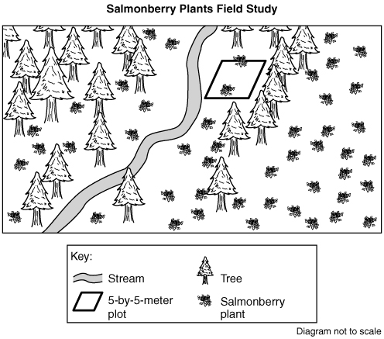
Directions: Use the following information to create a procedure for a related Experimental Question.

Salmonberry plants can be found all along the Pacific coast. Salmonberry plants are a food source for many animals in Pacific coast ecosystems including hummingbirds, deer, and bear. Scientists conducted a field study to learn about salmonberry plant populations in different habitats in Washington.

Field Study Question: How does the salmonberry plant population vary by habitat?

Procedure:
- Go to the salmonberry field study area. Record location, date, time, and temperature.
- Choose a random location in the forest edge habitat.
- Measure a 5-meter-by-5-meter plot and label as Plot 1.
- Count the number of salmonberry plants in Plot 1. Record as Plot 1 for the forest edge habitat.
- Repeat steps 2 through 4 for Plot 2 and Plot 3, choosing a new location in the forest edge habitat for each plot.
- Repeat steps 1 through 5 for the stream bank and forest habitats.
- Calculate and record the average number of salmonberry plants for each habitat.
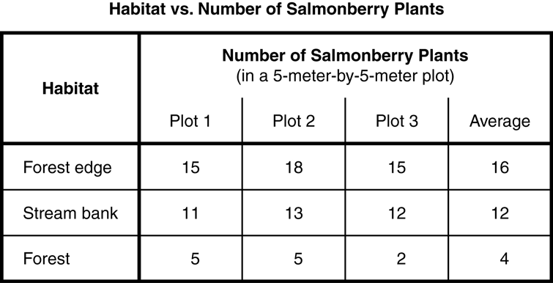

Data Collected:
Location: Forest edge, stream bank, and forest habitats Date and Time: May 1, from 11:00 A.M. to 2:00 P.M. Temperature: 10° C to 15° C

- Plan a field study to answer the question in the box. You may use any materials and equipment in your procedure.

Be sure your procedure includes:
- logical steps to do the field study
- conditions to be compared
- data to be collected
- method for collecting data
- how often measurements should be taken and recorded
- environmental conditions to be recorded

Field Study Question: How does the total rainfall in different years affect the mass of berries produced by a salmonberry plant?
Procedure:

Attribute | Score
- Method of Collecting Data
- Conditions to be Compared
- Data to be Collected
- Record Measurements
- Observations are repeated
- Extra Validity Measure
- Logical Steps
- Experimental and Control Groups
Total: | /8

