Feedback Loops
Directions: Diagram and provide a short explanation of how each of the following are examples of feedback.

Positive Feedback Loops
1) A Savings Account: Savings + Interest
2) A Shouting Match: Shouting + Anger
3) Exponential Growth: Rabbits + Births
4) Albedo Effect: Snow Melt + Surface Temperature
5) Epidemic: Number Infected + New Infections
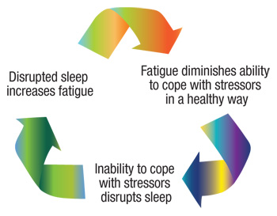
Resources Population
+
+
-
-
+
+
More More
Births Population
+

Negative Feedback Loops
1) Body Temperature: Desired Body Temperature + Heat Production by Body
2) Population Density: plants + sunlight
3) Population Stability: number of wolves + number of rabbits
4) Atmospheric temperature: temperature and windblown dust

(complete the following statement)
Based on the examples of negative feedback above, it seems like the purpose of a negative feedback mechanism is to

