*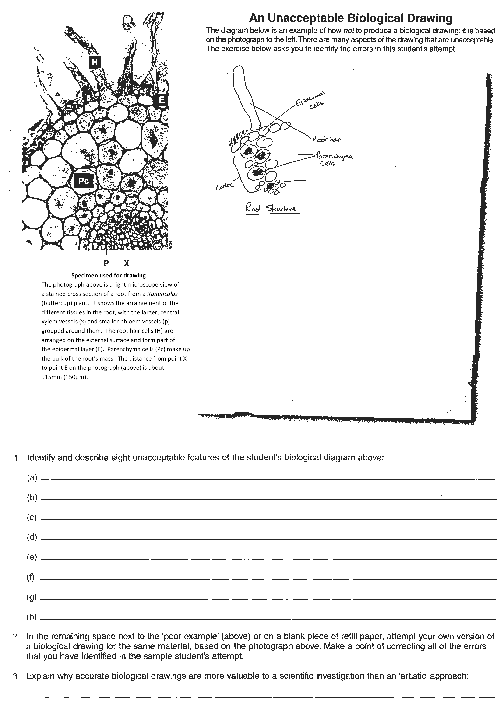***Unacceptable Drawing Revision**

9. Attempt your own version of the biological drawing using the correct rules

*C:\Users\quintone\AppData\Local\Microsoft\Windows\Temporary Internet Files\Content.IE5\YDWCCOM1\MC900445612[1].wmf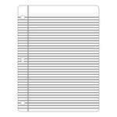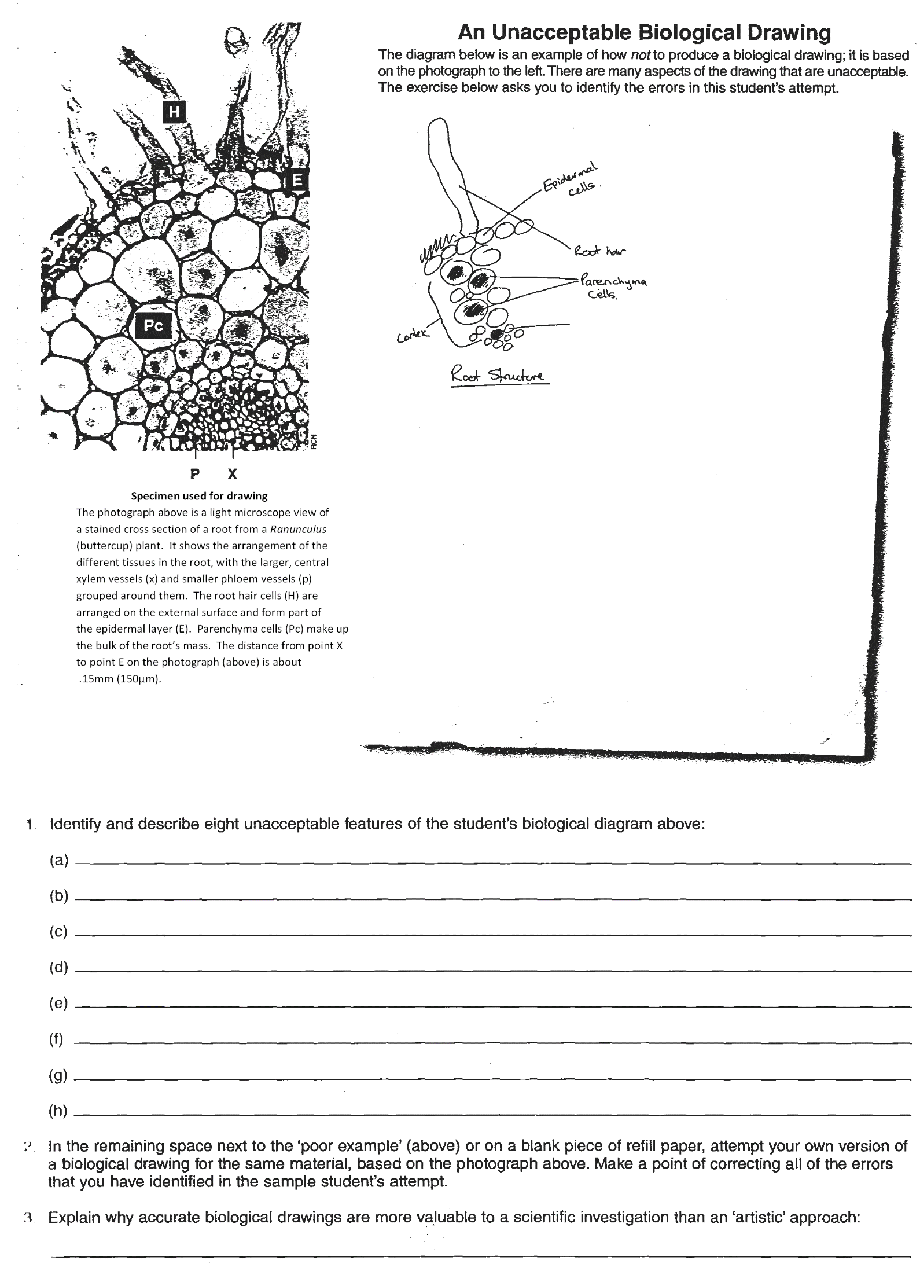*

The diagram below is an example of how **not** to produce a biological drawing; it is of the photograph above. There are many aspects of the drawing that are unacceptable. Identify/describe eight unacceptable features of the student’s biological diagram.

3

2

1.

2.

3.

4.

5.

6.

7.

8.

10. Explain why accurate biological drawings are more valuable to a  
scientific investigation that an “artistic” approach.